

# 6 DAYS BIG FIVE & GORILLA TREK BY HELICOPTER

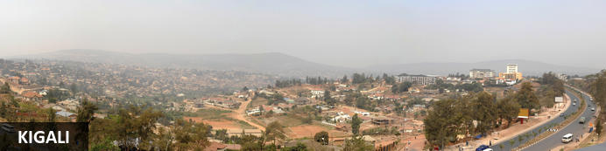

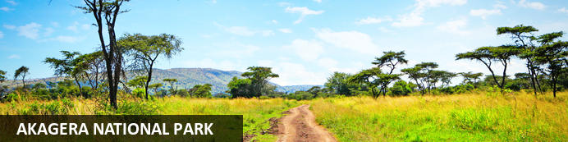

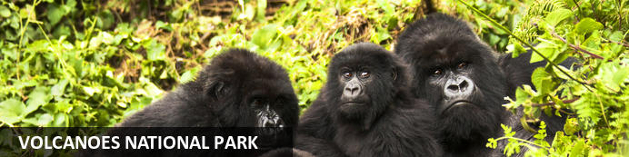

# 6 DAYS BIG FIVE & GORILLA TREK BY HELICOPTER

*Kigali - Akagera National Park - Volcanoes National Park*  
*6 Days / 5 Nights*  
*0 Persons*

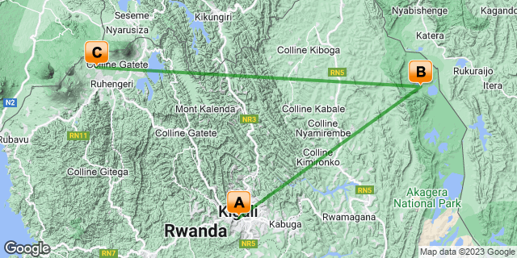

## Introduction

|  |  |  |  |  |
| --- | --- | --- | --- | --- |
| **Start** | **Accommodation** | **Destination** | **Basis** | **Duration** |
| Day 1 | Kigali Marriott Hotel | Kigali | HB | **1 Night** |
| Day 2 | Wilderness Magashi | Akagera National Park | FB+ | **2 Nights** |
| Day 4 | One & Only Gorilla's Nest | Volcanoes National Park | B&B | **2 Nights** |

**Key**  
HB: Half Board - Dinner, Bed and Breakfast  
B&B: Bed and Breakfast  
FB+: Full Board Plus - Dinner, Bed, Breakfast, Lunch and Activities

## Included

•    Meet and greet assistance on arrival  
•    Airport and inter-hotel transfers from day 1 to the last day  
•    All activities as highlighted in the itinerary.  
•  1 Night accommodation in Kigali at Kigali Marriott Hotel.   
•    2 Nights at Accommodation at Magashi Camp includes: - All meals, All local drinks (excludes premium imported brands and champagne), Laundry, Complimentary in-room welcome massage (**additional massages would be for guest's own account), Wireless internet connection in room only, Local Government taxes. In the event of a change in local taxes  
•   2 Nighst at One & Only Gorilla's Nest Lodge  includes breakfast, lunch, and dinner daily, minibar, non-alcoholic beverages, alcoholic house beverages with meals   
• All activities at Magashi Camp as per the lodge schedule.   
•    1 Gorilla permit per person (this includes briefing at RDB offices, guide, and trek – US$ 1500.-)  
•    1 Golden monkey permit per person (this includes briefing at RDB offices, guide, and trek – US$ 100.-)  
 RDB offices, guide, and trek.  
• Exclusive use of a private safari land cruiser  4x4 with WI-FI in receptive areas  
• Exclusive use of a private helicopter for all the journeys through your safari.  
•Services of a professional, experienced English-speaking Uber Luxe driver guide.  
•Village/ Cultural Visit to Volcanoes.  
•Bottled mineral water in the vehicle during the tour.  
•Our assistance.

## Excluded

* International and domestic airline tickets unless where indicated,
* All extra activities, visits, entrances and extra meals/drinks not  mentioned in the itinerary
* Entry visa fees,
* Optional extras whilst in Kigali
* Drinks throughout the trip,
* Tips and gratuities,
* Personal expenses such as telephone calls, mini bar, porter-age, travel insurance, etc.

## Day 1: Kigali Marriott Hotel, Kigali

### Kigali

Rwanda’s capital and biggest city stretches across lush undulating hills surrounded by towering mountains, the largest of which is Mount Kigali, rising 1850 metres above sea level. Kigali is the country’s financial, commercial and cultural hub, served by an international airport and featuring a wide range of accommodation options. It also offers a collection of restaurants and points of interest, including the Kigali Genocide Centre, an atmospheric market and numerous craft shops. With its interesting architecture, busy streets, meandering boulevards, and green hillsides, Kigali is said to be one of the most attractive cities in Africa and is definitely worth a visit.

### Day Itinerary

* TBA: Arrival time flight time into Kigali Rwanda.
* TBA: VIP Meet & Greet through immigration.
* TBA: Pick up from Kigali International Airport for a 25 minutes transfer to your hotel.
* TBA: Arrival at your hotel for Check-in.
* TBA Overnight stay and dinner at your hotel in Kigali.

### Overnight: Kigali Marriott Hotel

Experience the highest standard of comfort and convenience at Kigali Marriott Hotel. This premier luxury business hotel in Kigali is conveniently located along KN3 Avenue in downtown Kigali, close to the financial district, embassies, government ministries and Kigali City Hall. Timeless elegance surrounds you on arrival to a modern and spacious lobby and grand stairs. Experience spacious guest rooms decorated in warm pastel colors and fitted with the latest in technology. Visit Cucina Restaurant for tasty, innovative Italian fare and Lobby Bar for cocktails and city vistas. Complete your stay with a day of pampering at Saray Spa, the largest spa in the city, with its 5-star treatments and outdoor pool. Featuring the largest meeting space in the city, the hotel in Kigali is ideal for hosting productive conventions, elegant weddings and retreats of all sizes. Whether here for business or leisure, their Kigali luxury hotel offers all the amenities you'll need for an unforgettable retreat in Kigali, Rwanda.

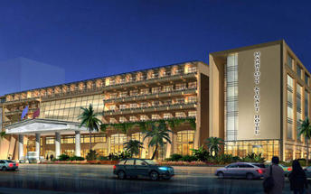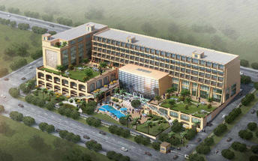

### Basis

Half Board - Dinner, Bed and Breakfast

## Day 2: Wilderness Magashi, Akagera National Park

### Akagera National Park

Bordering Tanzania in eastern Rwanda, Akagera National Park is central Africa's largest protected wetland and the last refuge for savannah-adapted species in the country. Stretching across a vast expanse of low-lying mountains and savannah plains, the park takes in the rolling highlands woodlands, swamp-fringed lakes, and wetlands of the Kagera River along the way. Crocodiles and hippos wallow in the park's watery basins, predators prowl through its acacia groves, and elephant, zebra, giraffe, buffalo and other animals roam across its grassy plains. Bursting with a rich biodiversity, the park features a variety of rare species, as well as a plentitude of mammals and hundreds of bird species.

### Day Itinerary

* 0830: Transfer to Kigali Genocide Museum.
* 0900: Visit the **Kigali** **Genocide memorial center**.
* 1015: Transfer to Kigali airport for your helicopter flight to Nyungwe
* 1100: Helicopter flight to Akagera National Park.
* 1130: Arrive and check in at Akagera National Park.
* 1300: Rest of the day relaxation or part of the complimentary activities at the Resort.
* 1830: Dinner and overnight stay at the Resort.

### Overnight: Wilderness Magashi

Wilderness Magashi is situated in the productive and phenomenally diverse north-eastern corner of Akagera National Park, overlooking scenic Lake Rwanyakazinga. Akagera comprises some of the most scenic savannah in East Africa – open plains, woodlands, lakes, swamp and grassy low mountains – and is home to one of Africa’s highest hippo densities, large crocodiles, as well as the rare sitatunga and boasting an impressive 520 species of birds. Teeming with plains game, Akagera now also boasts a healthy population of lion which were introduced by African Parks in 2015 after a 20-year absence; black rhino were reintroduced in 2017, and white rhino in 2021. Wilderness Magashi – the only exclusive-use area in Akagera – also harbours a good density of leopard.

INSIDER'S TIP: Our core Purpose in Akagera is to help conserve Rwanda’s last protected savannah ecosystem, and species like black rhino and the rare and elusive shoebill; furthermore, our presence here will contribute towards enabling it to become economically self-sufficient for the first time.

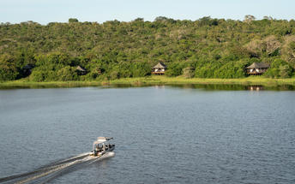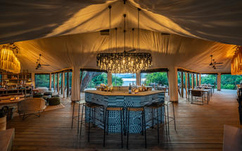

### Activities

|  |
| --- |
| Kigali Genocide Memorial & Museum |

#### Kigali Genocide Memorial & Museum

Located just outside of Kigali City Centre in the Gasabo district, Kigali Genocide Memorial & Museum was created by a joint partnership of the Kigali City Council and the UK-based Aegis Trust. The centre is an extremely moving, challenging, educational and ultimately inspiring as well as a great place to understand the cause, tragedy and successful rebuilding post-genocide.

The memorial hosts a tour which is transparent and educational but very sombre and humbling when guests realise that over 250,000 deceased are buried on the site of the memorial.

### Basis

Full Board Plus - Dinner, Bed, Breakfast, Lunch and Activities

## Day 3: Wilderness Magashi, Akagera National Park

### Day Itinerary

* 0630: Begin the day with a morning breakfast.
* 0700: Morning **game drive** in Akagera National Park and other day activities by the lodge.
* 1400: **Boat safari in Akagera** on Lake Rwanyakizinga.
* 1800: Dinner and overnight stay at Magashi Camp.

### Activities

|  |
| --- |
| Magashi Game Drives |
| Magashi Boating |

#### Magashi Game Drives

Explore the area in an open 4x4 vehicle with each vehicle able to accommodate a maximum of seven guests, allowing each individual an outside seat.

#### Magashi Boating

Magashi offers boating in eight-seater swamp cruisers. This is an excellent way to view the water birds and many other aquatic animals seen around Lake Rwanyakazinga.

### Basis

Full Board Plus - Dinner, Bed, Breakfast, Lunch and Activities

## Day 4: One & Only Gorilla's Nest, Volcanoes National Park

### Volcanoes National Park

Bordering the Democratic Republic of Congo in Rwanda, and set high on the jungle-covered slopes of the volcanic Virunga Mountains, the Volcanoes National Park is best known as a sanctuary for the region’s rare mountain gorillas. Visitors flock here to experience face to face encounters with these intriguing creatures. Regulated treks through the reserve allow visitors to spend an hour at a time with these incredible primates in their natural habitat. While the gorillas are without a doubt the main drawcard, visitors can also look forward to exploring a network of scenic hiking trails, with the beautiful day hike to the crater lake on Mount Bisoke being a particular highlight. Make sure to visit the fascinating Karisoke Research Centre and the tomb of the world-famous Dian Fossey.

### Day Itinerary

* 0900: Begin the day with a morning breakfast.
* 1100: Prepare to take your helicopter flight to Volcanoes.
* 1145: Estimated arrival time to Musanze airstrip.
* 1150: Pick up and transfer to One & Only Gorilla's Nest Lodge.
* 1230: Lunch at the Lodge and an entire day relaxing and winding at the Lodge.
* 1500: Take on any complementary activities at the lodge.
* 1830: Dinner at the Resort.

### Overnight: One & Only Gorilla's Nest

Cushioned in the foothills of the breathtaking Virunga Volcano range, One&Only Gorilla’s Nest makes the magical possible as you enjoy a once-in-a-lifetime, personal encounter with the rare and majestic mountain gorilla, roaming free in its own natural habitat. Offering an exclusive front-row seat to the world’s most popular mountain gorilla sanctuary. You’ll be captivated as exotic colourful birds and one of the planet’s greatest array of primate species flourish before your eyes and welcome you into their world. Then retreat to your own world, a spectacular modern haven, where every creature comfort is yours to behold. An all-inclusive resort, guests can look forward to savoring locally inspired dishes and taking part in two complimentary daily on-resort experiences.

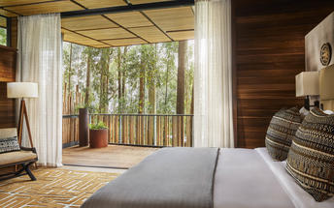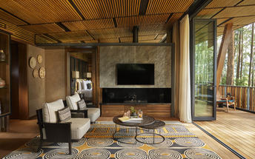

### Basis

Bed and Breakfast

## Day 5: One & Only Gorilla's Nest, Volcanoes National Park

### Day Itinerary

* 0600: Begin the day with a morning breakfast.
* 0630: Transfer to the park headquarters for gorilla trekking briefing.
* 0800: Start the **gorilla trekking in Volcanoes National Park.**
* 1200: Estimated time of returning from the jungle.
* 1230: Transfer back to the Lodge
* 1300: Lunch for the day.
* 1500: Visit **Iby ‘Iwacu cultural village.**
* 1800: Dinner and overnight stay at the One &Only Gorillas Nest Lodge.

### Activities

|  |
| --- |
| Gorilla Trekking Volcanoes National Park |
| Iby'Iwacu Cultural Village |

#### Gorilla Trekking Volcanoes National Park

Gorilla Trekking in the Volcanoes National Park offers visitors the unique opportunity of discovering the 10 families of gorillas that live within the national park. Visitors can enjoy a cup of coffee before the trek starts and will be separated into groups of 8 depending on their physical abilities. Each group is guided by a guide and two scouts who are well trained in emergency situations. The amount of time set aside per trek is different depending on where the gorilla family is situated. Some trips may take as little as half an hour and some taking the better part of the day.

#### Iby'Iwacu Cultural Village

Offering an adventurous stay in a traditional rural, Rwandan village that has existed for centuries living with and next to mountain gorillas in Parc National des Volcans. Iby’Iwacu Cultural Village gives you a rare chance to meet local people, in their environment, with a taste of our culture and traditions. The community you visit will genuinely welcome you as a special guest while they proudly present to you aspects of their traditions and beliefs. This will truly be an experience of a lifetime as you home stay with the community and become part of their family

### Basis

Bed and Breakfast

## Day 6: End of Itinerary

### Day Itinerary

* 0600: Begin the day with a morning breakfast.
* 0630: Transfer to the park headquarters for the golden monkey trekking briefing.
* 0800: Start the **Golden Monkey trek.**
* 1130: Estimated time of returning from the jungle.
* 1200: Transfer back to the lodge for Lunch.
* 1400: Helicopter flight back to Kigali.
* 1430: Arrival at the airport.
* 1530: Onwards for your departure flight
* End of service.

### Basis

Bed and Breakfast

# Transport

## Flight Information

|  |  |  |  |  |  |  |  |  |
| --- | --- | --- | --- | --- | --- | --- | --- | --- |
| **Date** | **Flight** | **Airline** | **Departure Airport** | **Time** | **Arrival Airport** | **Time** | **Class** | **Ref** |
|  | Charter Flight |  | Kigali Marriott Hotel |  | Wilderness Magashi |  |  |  |
|  | Charter Flight |  | Wilderness Magashi |  | One & Only Gorilla's Nest |  |  |  |
|  | Charter Flight |  | One & Only Gorilla's Nest |  | Kigali International Airport [KGL] |  |  |  |

## Transfers

|  |  |  |  |  |  |
| --- | --- | --- | --- | --- | --- |
| **Date** | **Company** | **Pick Up** | **Drop Off** | **Time** | **Vehicle** |
|  |  | Kigali International Airport [KGL] | Kigali Marriott Hotel |  | Transfer |