

# 10 Days Best of Uganda Safari Tour Safari

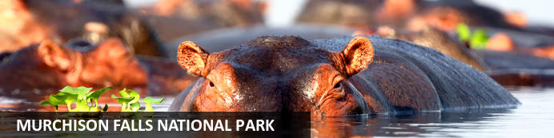

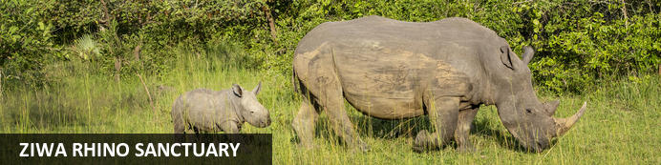

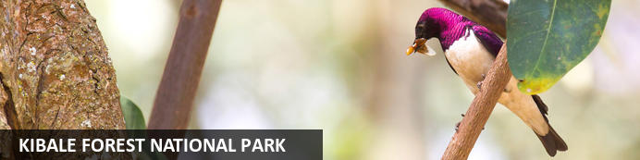

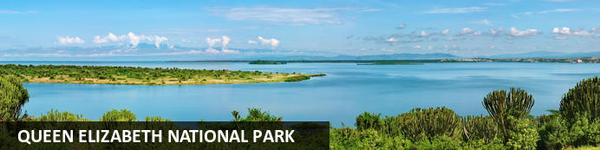

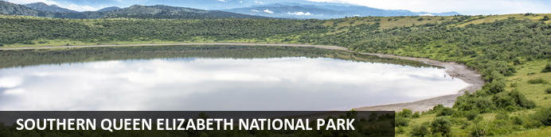

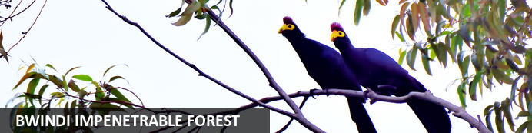

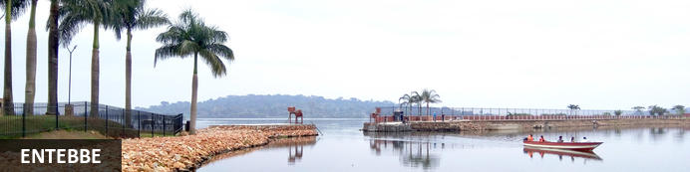

# 10 Days Best of Uganda Safari Tour Safari

*Murchison Falls National Park - Ziwa Rhino Sanctuary - Kibale Forest National Park - Queen Elizabeth National Park - Southern Queen Elizabeth National Park - Bwindi Impenetrable Forest - Entebbe*  
*10 Days / 9 Nights*  
*0 Persons*  
*Date of Issue: 28 September 2023*

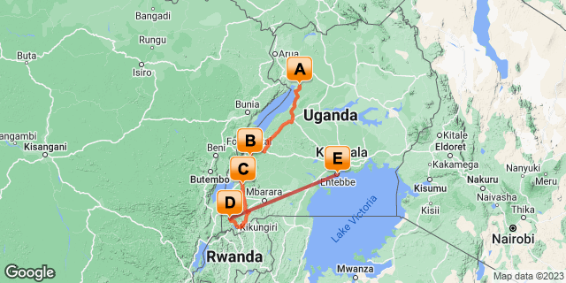

## Introduction

|  |  |  |  |  |  |  |
| --- | --- | --- | --- | --- | --- | --- |
| **Start** | **Accommodation** | **Type** | **Destination** | **Basis** | **Room Type** | **Duration** |
| Day 1 | Nile Safari Lodge |  | Murchison Falls National Park | FB | 1x Deluxe | **2 Nights** |
|  | → Paraa Safari Lodge | alternate |  |  |  |  |
| Day 3 | Ndali Lodge |  | Kibale Forest National Park | FB |  | **2 Nights** |
|  | → Turaco Treetops | alternate |  |  |  |  |
| Day 5 | Kyambura Gorge Lodge |  | Queen Elizabeth National Park | FB |  | **2 Nights** |
|  | → Mweya Safari Lodge | alternate |  |  |  |  |
| Day 7 | Sanctuary Gorilla Forest Camp |  | Bwindi Impenetrable Forest | FB |  | **2 Nights** |
|  | → Mahogany Springs Lodge | alternate |  |  |  |  |
| Day 9 | No.5 Boutique Hotel |  | Entebbe | FB |  | **1 Night** |
|  | → Protea Hotel by Marriott Entebbe | alternate |  |  |  |  |

**Key**  
B&B: Bed and Breakfast  
FB: Full Board - Dinner, Bed, Breakfast and Lunch

## Included

* Airport transfers.
* Transportation by a 4WD safari land cruiser
* One-way flight from Bwindi to Entebbe.
* Accommodation and meals are as per the itinerary.
* All boat trips.
* Hike to the top of Murchison Falls.
* One Gorilla permit per person is to be secured and paid for in advance US$ 700.00.
* Park fees.
* Bigodi Wetland walk
* Kibale Chimpanzee permit US$ 200.00
* Community visits.
* Ziwa Sanctuary Rhino Tour.
* Services of English-speaking driver/guide.
* Enroute lunches.
* Game drives.
* Batwa Cultural Experience.
* Bush walk
* A guided nature walk Bigodi.
* Bottled drinking water throughout the safari
* All government taxes.
* Our assistance

## Excluded

* Other drinks.
* Laundry.
* Tips to local guides.
* Telephone expenses.
* Porter fees while trekking Gorillas and chimpanzees.
* Personal insurance.
* Cigarettes.

## Day 1: Nile Safari Lodge, Murchison Falls National Park

### Murchison Falls National Park

Stretching from the shores of Lake Albert, Murchison Falls National Park is Uganda's largest National Park. The Nile River flows through the middle of the park creating the impressive Murchison Falls which is the park’s major attraction. The landscape features dense rainforest, undulating savannah and a diversity of abundant wildlife. Visitors can enjoy prime game-viewing along the Buligi Circuit. The forests are home to numerous primates, including Chimpanzees, and near the river, buffalo, elephants and Rothschild-Giraffes can be seen. Other commonly spotted wildlife include: lions, antelope, waterbucks, hippos and crocodiles.

### Day Itinerary

•          0700: Pick up on arrival at Entebbe International Airport.   
•          0730: Begin the drive to Murchison Falls National Park.  
•          1100: Arrival at the **Ziwa Rhino Sanctuary for Rhino trekking**  
•          1230: Lunch at the Sanctuary.  
•          1430: Proceed to the Park  
•          1600: Arrival at the Park and the rest of the afternoon is dedicated to relaxation.  
•          1830: Dinner and overnight stay.

### Overnight: Nile Safari Lodge

Nile Safari Lodge is a luxury eco-friendly safari lodge located on the Victoria Nile River banks in Uganda. The lodge is situated in the heart of the Murchison Falls National Park and offers spectacular views of the river and endless game viewing opportunities. Accommodation includes eight secluded bandas equipped with en-suite facilities, a private view deck with deck chairs and a mosquito net. Guests may enjoy delicious meals at the on-site restaurant.

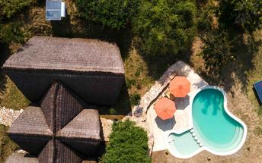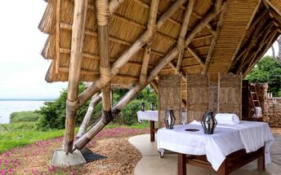

### Alternate: Paraa Safari Lodge

Paraa Safari Lodge is situated in Murchison Falls National Park, northwest Uganda. It overlooks nature's best-kept secrets, the River Nile, on its journey from its source at Lake Victoria. The lodge accommodation options include cottages, suites, double, twin and single rooms featuring fans, balconies and en-suite bathrooms. During their stay, guests can enjoy delicious local and international specialities at the on-site restaurant. Leisure facilities include a swimming pool, bar and a gift shop.

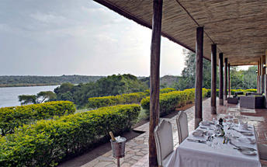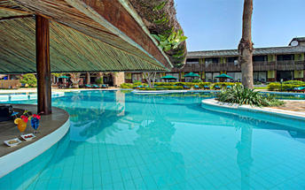

### Activities

|  |
| --- |
| Ziwa Rhino Sanctuary |

#### Ziwa Rhino Sanctuary

Located north of Kampala in the Nakasongola district of Uganda, The Ziwa Rhino Sanctuary is the only place in the country with wild rhinos. Currently home to twenty two southern white rhinos, the sanctuary offers rhino trekking, shoebill trekking, canoeing, bird watching, and night walks. Visitors may also spot a range of other species including Uganda kobs, oribis, bush bucks, and water bucks. The prehistoric-looking shoebill stork is one of the most sought after birds in Uganda, and the sanctuary is one of the only places where they can almost always be seen. See over 300 bird species along bird trails through the woodlands, swamp and savannah, and take a guided night walk, where you will be introduced to extraordinary night sounds and sensations, including a beautifully clear night sky and several nocturnal animals.

### Basis

Full Board - Dinner, Bed, Breakfast and Lunch

## Day 2: Nile Safari Lodge, Murchison Falls National Park

### Day Itinerary

•          0600: Begin the day with a cup of coffee.  
•          0615: Start off your **dawn game safari drive**.     
•          0900: Return from your game drive for a full breakfast and refreshments.  
•          1200: Lunch at the Lodge  
•          1330: Transfer to catch up a boat ride along the Nile at 14h00.  
•          1400: Proceed for 3 hrs. **Boat safari along the Nile River**  
•          1630: **Hike to the top of the falls.**  
•          1830: Dinner and overnight stay.

### Activities

|  |
| --- |
| Murchison Falls National Park Game Drive |
| Murchison Falls Boat Trip |
| Murchison Falls National Park Hiking To The Top Of The Falls |

#### Murchison Falls National Park Game Drive

The Murchison Falls National Park Game Drive takes place in the Murchison Falls National Park. The main areas of the drive are the Delta, Buligi Peninsula and the southern section which is known as the heart of Murchison. The Delta allows visitors an opportunity to see Lions, while the triangle of grassland in the Buligi Peninsula provides an opportunity to see elephant, buffalo, antelopes, and giraffes. This grassland is bound by the Victoria Nile entering Lake Albert with the Albert Nile flowing out of it. Lions, leopard, and waterbirds along with hippos can also be spotted here. Much of the southern part is populated with dense bush and forest, where lions and giraffes can also be seen.

#### Murchison Falls Boat Trip

Launches run from Paraa to the base of the Falls. The three hour return journey is for many a highlight of a trip to Murchison. Along the river there are thousands of hippos, enormous crocodiles, amazing bird life a possible sighting of the rare shoebill.

A boat trip from Paraa to the Delta where the Victoria Nile enters Lake Albert offers excellent game viewing and birding opportunities and takes about five hours.

#### Murchison Falls National Park Hiking To The Top Of The Falls

Murchison Falls National Park Hiking To The Top Of The Falls is a leisurely 45-minute hike to the top of the falls, exposing participants to Mother Nature's wondrous gorge, also known as devils cauldron. The rejuvenating activity takes participants along a trail which overlooks spectacular views of the Nile and landscape of Murchison falls national park while offering amazing bird watching opportunities.

### Basis

Full Board - Dinner, Bed, Breakfast and Lunch

## Day 3: Ndali Lodge, Kibale Forest National Park

### Kibale Forest National Park

Kibale Forest National Park, situated in Western Uganda, is famous for its high density of primates, breathtaking crater lakes, and thick, beautiful jungle. Thirteen primate species inhabit the beautiful tropical forest, including red-tailed monkey, L’Hoest's monkey, grey-cheeked mangabey, red colobus, and black and white colobus monkeys. Visitors may spot some of the 300 bird species and 250 butterfly species, and buffalo, forest elephants, leopards, bushbucks, and sitatungas also live in the park but are generally shy. The area is decorated by around 50 enthralling crater lakes and numerous pristine hiking trails. Several cultural tours are on offer which delve into the rich traditions of the Batoro people, giving travellers a chance to see Batoro dancing, singing and traditional healing up close.

### Day Itinerary

•          0710: Begin the day with a cup of coffee.  
•          0810: Drive and transfer to Fort Port Portal.  
•          1300: Estimated time of arrival and lunch.   
•          1500: Afternoon relaxation at the Lodge.  
•          1830: Dinner and overnight stay at the lodge.

### Overnight: Ndali Lodge

Known as the 'Cradle of the Nile', Uganda is one of Africa's best kept secrets. Few countries can boast the infinite variety of flora and fauna and such diverse and spectacular scenery. Uganda has much to offer the first time visitor to Africa as well as veteran travellers.

Ndali Lodge is set stunningly amidst the Bunyaruguru crater lake region of Western Uganda, 26 kilometres south of Fort Portal lies at the centre of 1000 acres of privately owned fertile farmland still cultivated in a traditional style. A visit to Uganda would not be complete without experiencing the wonders Ndali has to offer.

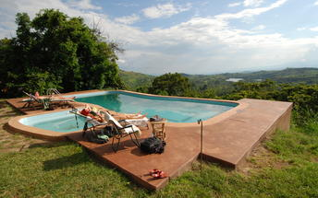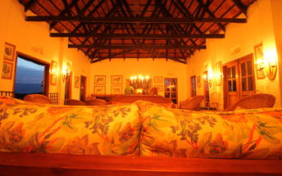

### Alternate: Turaco Treetops

Turaco Treetops is ideally located just outside the lush Kibale National Park, Uganda, where many birds, monkeys and butterflies that inhabit the Kibale Forest can also be found. The accommodation is in the form of cottages and rooms equipped with practical furniture, mosquito nets, comfortable beds, a private bathroom and a balcony with fantastic views over the canopy. Guests can enjoy all their meals in the main lodge's dining room or sit in the bar with a refreshing drink. Additional amenities and services include a swimming pool, a lounge area with a fireplace, a first-floor lounge with spectacular views over the forest and the snow-capped Rwenzori mountains and Wi-Fi. Guests can enjoy going on day/night forest walks, mountain bike tours and experience chimpanzee trekking.

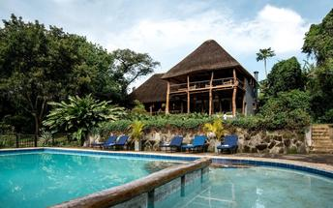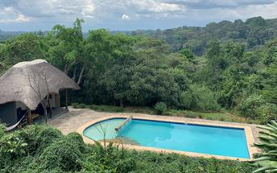

### Basis

Full Board - Dinner, Bed, Breakfast and Lunch

## Day 4: Ndali Lodge, Kibale Forest National Park

### Day Itinerary

•          0645: Begin the day with Breakfast.   
•          0730: Proceed to the park headquarters for the Chimpanzee trekking briefing.    
•          0800: Begin your **Chimpanzee Trekking Experience.**  
•          1230: Estimated time of returning from the Jungle.  
•          1300: Lunch at the Lodge.  
•          1500: Afternoon **Bigodi Wetland Walk.**  
•          1830: Dinner and overnight stay.

### Activities

|  |
| --- |
| Kibale Forest Chimp Tracking |
| Bigodi Wetland Sanctuary |

#### Kibale Forest Chimp Tracking

The most favourite of Kibale’s walks embarks on from the Kanyanchu Visitor center at 08.00 & 15.00 and lasts 2 to 3 hours. Chimpanzee are the most sought after primate by visitors, but you should look out for the black & white colobus, red tailed monkey or the grey cheeked mangabey. Your guides will be able to show you pittas & different bird species and will give details of the tradit of the plant species within the forest. This walk is for 6 people in a group.

#### Bigodi Wetland Sanctuary

The Bigodi Wetland Sanctuary is a community development enterprise located on the fringe of Kibale National Park where guided tours are conducted along a path through the wetland at time along boardwalk trail. Bigodi is a birder's paradise with 138 bird species having been identified there including the crowd please Great Blue Turaco. The sanctuary is also home to 8 primate species including the black and white colobus, red colobus, mangabey, red tail, vervet, and L’Hoest.

### Basis

Full Board - Dinner, Bed, Breakfast and Lunch

## Day 5: Kyambura Gorge Lodge, Queen Elizabeth National Park

### Queen Elizabeth National Park

Located in southwestern Uganda, the Queen Elizabeth National Park is one of the county’s most popular parks. Volcanic craters, grassy plains, tropical forest and giant lakes connected by a channel inhabited by abundant hippos, are what you will see at the Queen Elizabeth National Park. The park has almost 100 types of mammal and 606 different bird species, including the peculiar shoebill. The 40-kilometre-long Kasinga Channel alone is said to contain the world's largest concentration of hippos, and a guided boat trip here is a popular way to see the wildlife. Other species to spot include buffalo, the rare aquatic sitatunga antelope, giant forest hog, Uganda kob, Defassa waterbuck and elephant. Don't miss the chance to explore the dramatic Kyambura Gorge, is home to habituated chimpanzees.

### Day Itinerary

•    0800: Begin the day with a morning cup of coffee.  
•    1000: Drive to Queen Elizabeth National Park.   
•    1230: Lunch at the Lodge.  
•    1400: Relaxation at the lodge.   
•    1830: Dinner and overnight stay at the lodge.

### Overnight: Kyambura Gorge Lodge

This renowned Kyambura Gorge Lodge, with entirely remodelled public areas and gardens, has been converted from a coffee store to create a breathtakingly beautiful space. The lodge is located on the edge of Queen Elizabeth National Park with sweeping views of the rolling savanna, the distant mountains of the moon, and the sunken Kyambura Gorge.

The guest bandas have a afro-chic theme with the accent on local artifacts re-imagined in a new context. Each banda offers a unique view either across the savanna or the gorge. There are four new deluxe bandas and four standard bandas. A new spa and swimming pool was launched in 2019.

The lodge is the ideal location for tracking the lost chimps in the sunken forest of Kyambura Gorge nearby and seeing the amazing game in one of Africa’s most beautiful parks, centred around the waterway of the Kazinga Channel. The park has six hundred amazing bird species, the highest in an African park.

Guests can participate in the Kyambura Gorge Eco-tourism project, a series of community and conservation activities developed since 2009 to safeguard the Kyambura Gorge ecosystem.

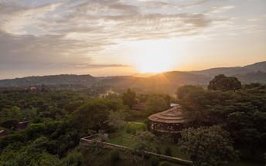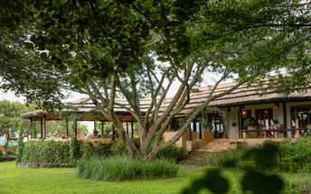

### Alternate: Mweya Safari Lodge

Mweya Safari Lodge offers visitors an unforgettable experience. Located on a peninsula within the heart of the Queen Elizabeth National Park, Mweya Safari Lodge is surrounded by the magical Rwenzori Mountains aptly described as the 'Mountains of the Moon' and overlooks the Kazinga Channel which links two of the Nile's great lakes – Lake George and Lake Edward. Mweya Safari Lodge offers visitors a spectacular experience of luxury in the wilderness. All of the rooms have wonderful views of the channel. The Lodge offers a range of activities and attractions: game drives, boat trips, wild life viewing and more.

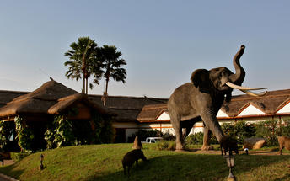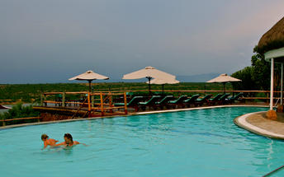

### Basis

Full Board - Dinner, Bed, Breakfast and Lunch

## Day 6: Kyambura Gorge Lodge, Queen Elizabeth National Park

### Day Itinerary

•    0600: Begin the day with a morning cup of coffee.  
•    0630: Step out for a **morning game drive along the Kasenyi plains**  
•    1030: Return to your lodge for a full breakfast and refreshments.   
•    1230: Lunch at the Lodge.  
•    1400: Embark on a 3hrs **boat safari begins along the famous Kazinga Channel**  
•    1800: Return to the Lodge.   
•    1830: Dinner and overnight stay at the lodge.

### Activities

|  |
| --- |
| Game Drive in Queen Elizabeth |
| Wild Frontiers Kazinga Channel Kingfisher Boat |

#### Game Drive in Queen Elizabeth

The Game Drive in Queen Elizabeth takes place in the open grasslands of Kasenyi in the Queen Elizabeth National Park. The park is a primary game viewing area due to the variety of wildlife which includes antelopes, elephants, buffalos, and lions. Visitors will be accompanied by an experienced guide able to track down these animals.

#### Wild Frontiers Kazinga Channel Kingfisher Boat

Wild Frontiers Kazinga Channel Kingfisher Boat is a leisurely boat cruise along the Kazinga Channel in Queen Elizabeth National Park. Passengers may encounter herds of elephant, buffalo and antelope, families of warthog, large groups of hippo, and crocodiles basking on the shore. Kazinga's shores are a haven for numerous birds, including many migratory species as they make their way south to warmer climates. The cruise also provides a spectacular view of the beautiful Mweya Peninsula and life in local fishing villages set along the banks.

### Basis

Full Board - Dinner, Bed, Breakfast and Lunch

## Day 7: Sanctuary Gorilla Forest Camp, Bwindi Impenetrable Forest

### Bwindi Impenetrable Forest

Located in southwestern Uganda, the Bwindi Impenetrable Forest is said to be Africa’s oldest rainforest. It is world-renowned for its excellent gorilla-sighting opportunities - the forest is home to half of the remaining mountain gorillas on earth. This gorilla experience takes place among a rugged landscape of dense jungle, cascading waterfalls, sparkling mountain streams, deep valleys, and steep ridges. The untouched forest has been declared a UNESCO World Heritage Site for its breathtaking natural beauty and unique ecological significance, and aside from the amazing gorilla interactions, there are other drawcards such as a network of forest walks, over 340 species of bird to spot, and a variety of brightly-coloured butterflies to identify. Don’t miss the opportunity to explore the spectacular Virunga Volcanoes, three of which are still active.

### Day Itinerary

•    0700: Begin the day with breakfast at your convenience.   
•    0800: Drive to Ishasha -South of Queen Elizabeth.   
•    1030: **Mid-morning game drives in Ishasha for the tree-climbing lions.**  
•    1300: Lunch break in Ishasha.  
•    1500: Drive to Bwindi to the south of the park   
•    1630: Estimated time of arrival and check-in  
•    1900: Dinner and overnight stay at the lodge.

### Overnight: Sanctuary Gorilla Forest Camp

Once-in-a-lifetime encounters with Uganda’s endangered gorillas await when you stay in one of these ten private luxury tents in the heart of the Bwindi Impenetrable Forest.

Ecologically respectful, contemporary-yet-classic in style, Sanctuary Gorilla Forest Camp blends in sensitively with the dramatic African mountain landscape and, situated uniquely inside the national park, you are only minutes away from the start of your gorilla trekking adventure.

Located in one of the remotest areas of Africa, these comfortable canvas spaces are dressed with indigenous prints and furniture made from natural materials. Beds are draped in neutral-toned linens, and local artefacts set a scene that ensures memorable moments both inside and out the accommodation. Each tent has a spacious, stone-walled bathroom with private sections, and a free-standing bath for a relaxing soak after a day’s trekking. The trees around the camp light up in the morning when the sun starts shining, and thanks to there being so few tents, the camp retains an intimate, exclusive feel, enabling you to experience Africa’s magic with the lightest of footprints yet with practically every mod con.

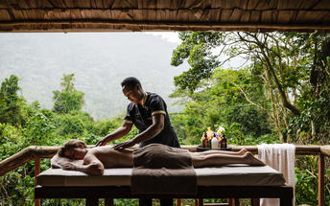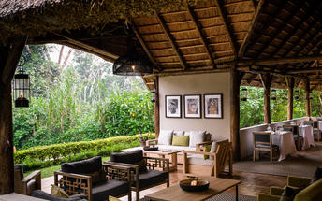

### Alternate: Mahogany Springs Lodge

Mahogany Springs is situated in one of the most intimate, secluded, beautiful and most importantly natural settings in the world and only around 2 minutes away from the Gorilla tracking starting point.

All the rooms at Mahogany Springs are high end suites. All Suites can be twin, double or triple. There is 24/7 power in all the rooms. All rooms have large en-suite bathrooms with a gorgeously designed open terracotta shower.

All 12 luxurious suites have their own private terrace with magnificent panoramic views over the grounds, river and surrounding areas.

The main dining area is exquisitely furnished and with panoramic views beyond the lodge’s own gardens you will enjoy dining in a tranquil and unrivalled setting. The service provided is as much an art form as the food therefore, the staff are trained to very high standards. Within the main building there is a stunning bar where guests can sit all day and night trying one of the many cocktails or simply a bottle of fine wine. Most of the produce used at Mahogany Springs is grown on site to provide guests with the freshest ingredients.

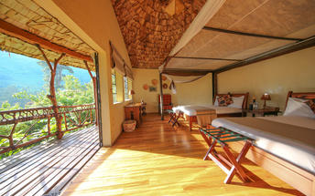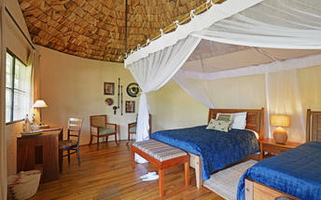

### Activities

|  |
| --- |
| Ishasha Game Drive |

### Basis

Full Board - Dinner, Bed, Breakfast and Lunch

## Day 8: Sanctuary Gorilla Forest Camp, Bwindi Impenetrable Forest

### Day Itinerary

•    0600: Begin the day with a cup of coffee.   
•    0630: Ready for a morning transfer to the park headquarters for your gorilla trekking briefing.        
•    0800: **Gorilla trekking starts.**  
•    1300:  Estimated time of returning from the jungle back to your lodge.  
•    1330: Lunch at the Lodge.  
•    1500: Afternoon **Batwa Village experience.**  
•    1830: Dinner and overnight stay.

### Activities

|  |
| --- |
| Gorilla Trekking Bwindi Impenetrable Forest |
| Batwa Cultural Village |

#### Gorilla Trekking Bwindi Impenetrable Forest

Wake early for a hearty breakfast to give you the energy needed for gorilla trekking. Before 8:00 am, report to the ranger station for registration and a talk by one of the rangers. The guides will then take you through the bush, pushing your way through the undergrowth, to track the gorillas. (Please note this trek can take from 30 minutes to 5-6 hours). A reasonable degree of fitness is required, as well as a sturdy pair of walking shoes. Sit in the forest among the gorillas, listening to them ‘talk’ to one another, and marvel at the sheer size of the dominant male, the Silverback. It is an extraordinary feeling sitting in the dense rainforest knowing you are with a few of the last remaining mountain gorillas. It's amazing to think there are only about 650 of these beautiful creatures left.

#### Batwa Cultural Village

The Batwa Cultural village is where the Batwa (Pigmies) still live in the same way they used to years ago in tree houses. The Batwa only began leaving their forest homes around 15 years ago and they have been able to remain on this land thanks to the support of a generous American benefactor who donated the land back to them and created a cultural program. The fees from visiting tourists and are given to the Batwa project and they delight in welcoming visitors to their village and demonstrating how they make weapons, dance, make fires using sticks and cook.

### Basis

Full Board - Dinner, Bed, Breakfast and Lunch

## Day 9: No.5 Boutique Hotel, Entebbe

### Entebbe

Situated on a peninsula in Lake Victoria, the former seat of Uganda’s government, Entebbe is just a short drive from the current capital and offers plenty to keep visitors amused. This charming town features tree-lined streets and serves as an excellent base from which to explore the surrounding area. Tourists can look forward to spending days on beautiful beaches along the banks of Lake Victoria, stroll through the fields and forests of the magnificent Botanical Gardens, or pay a visit to Ngamba Island Chimpanzee Sanctuary, a haven for country’s orphaned chimps.

### Day Itinerary

* 0700: A day starts with breakfast.
* 0800: transfer to Kihihi Airstrip.
* 0925: Fly to Entebbe
* 1125: The flight arrives in Entebbe and be picked up by your guide.
* 1140: Transfer to your hotel in Entebbe for Lunch.
* 1900: Dinner is served at the Lodge.

### Overnight: No.5 Boutique Hotel

Nestled in the leafy suburbs of Entebbe, is the new and stylish boutique hotel, Hotel No.5. From the moment you arrive, you are warmly welcomed and cared for. With luxurious rooms opening onto the garden and swimming pool, this is a great option for guests looking for an intimate stay in a tranquil setting.

Make yourself at home – unwind beside the swimming pool, pamper yourself with a spa treatment, or work up a sweat in the hotel gym. For one of the most flavoursome dining experiences in Entebbe, carefully planned menus are paired to an international wine list, and served with pride.

Attention to detail and an attentive guest experience are synonymous with Hotel No. 5, making it the perfect choice for a restful stay in this busy town.

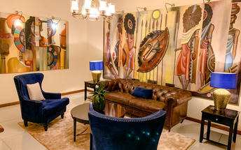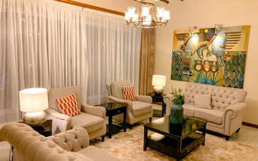

### Alternate: Protea Hotel by Marriott Entebbe

This 73-roomed hotel is ideally located on the glistening shores of Lake Victoria and a convenient 1km from the airport. Protea Hotel by Marriott Entebbe has a restaurant that offers an exciting and truly inviting a la carte menu seven days of the week. Specialties include Tilapia and Nile Perch, while guests can also relax on the terrace and bar. It’s a hotel that complements your travel style. With elegant furnishings and a warm, inviting feel, the hotel’s decor and rooms create a luxurious atmosphere. The outside terrace, with its own special ambience and superb lake views is the perfect place to take it all in.

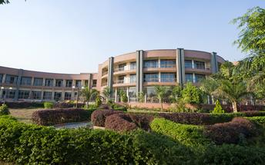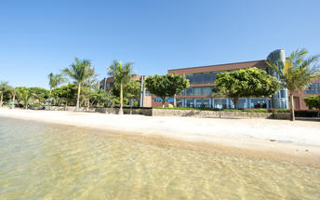

### Basis

Full Board - Dinner, Bed, Breakfast and Lunch

## Day 10: End of Itinerary

### Day Itinerary

•    0800: Begin the day with a cup of coffee.   
•    TBA: Transfer to the airport for your outbound flight  
•    TBA: Flight time to be advised.   
End of service.

### Basis

Bed and Breakfast

# Transport

## Flight Information

|  |  |  |  |  |  |  |  |  |
| --- | --- | --- | --- | --- | --- | --- | --- | --- |
| **Date** | **Flight** | **Airline** | **Departure Airport** | **Time** | **Arrival Airport** | **Time** | **Class** | **Ref** |
|  | Scheduled |  | Sanctuary Gorilla Forest Camp |  | No.5 Boutique Hotel |  |  |  |

## Transfers

|  |  |  |  |  |  |
| --- | --- | --- | --- | --- | --- |
| **Date** | **Company** | **Pick Up** | **Drop Off** | **Time** | **Vehicle** |
|  |  | Entebbe International Airport [EBB] | Nile Safari Lodge |  | Transfer |
|  |  | Nile Safari Lodge | Ndali Lodge |  | Transfer |
|  |  | Ndali Lodge | Kyambura Gorge Lodge |  | Transfer |
|  |  | Kyambura Gorge Lodge | Sanctuary Gorilla Forest Camp |  | Transfer |
|  |  | No.5 Boutique Hotel | Entebbe International Airport [EBB] |  | Transfer |