

# 3 Days Chimpanzee Tracking Safari in Kibale National Park

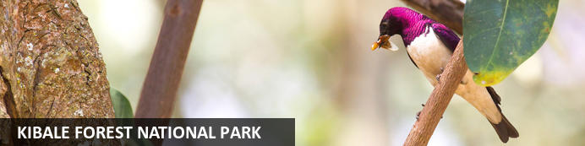

# 3 Days Chimpanzee Tracking Safari in Kibale National Park

*Kibale Forest National Park*  
*3 Days / 2 Nights*  
*0 Persons*  
*Date of Issue: 13 September 2023*

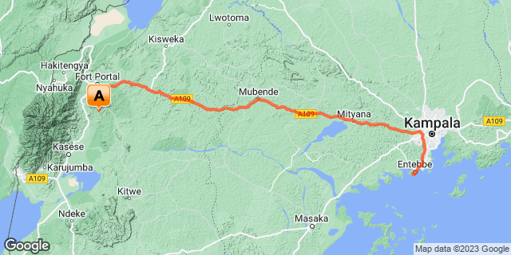

## Introduction

|  |  |  |  |  |  |
| --- | --- | --- | --- | --- | --- |
| **Start** | **Accommodation** | **Type** | **Destination** | **Basis** | **Duration** |
| Day 1 | Ndali Lodge |  | Kibale Forest National Park | FB | **2 Nights** |
|  | → Kyaninga Lodge | alternate |  |  |  |
|  | → Turaco Treetops | alternate |  |  |  |

**Key**  
B&B: Bed and Breakfast  
FB: Full Board - Dinner, Bed, Breakfast and Lunch

## Included

* All ground transportation in a Safari Land cruiser
* Chimpanzee trekking permits
* Services of an English-speaking guide.
* Full board accommodation as per the itinerary
* Bottled water for highland areas.
* Crater walk tour
* Bigodi Wetland Visit.
* Park entrance and conservation fees.
* All government taxes
* Our assistance

## Excluded

* International flights,
* Personal Travel insurance,
* Visa Fees,
* Premium drinks,
* Cigarettes,
* Tips, souvenirs, and any other items of personal nature.

## Day 1: Ndali Lodge, Kibale Forest National Park

### Kibale Forest National Park

Kibale Forest National Park, situated in Western Uganda, is famous for its high density of primates, breathtaking crater lakes, and thick, beautiful jungle. Thirteen primate species inhabit the beautiful tropical forest, including red-tailed monkey, L’Hoest's monkey, grey-cheeked mangabey, red colobus, and black and white colobus monkeys. Visitors may spot some of the 300 bird species and 250 butterfly species, and buffalo, forest elephants, leopards, bushbucks, and sitatungas also live in the park but are generally shy. The area is decorated by around 50 enthralling crater lakes and numerous pristine hiking trails. Several cultural tours are on offer which delve into the rich traditions of the Batoro people, giving travellers a chance to see Batoro dancing, singing and traditional healing up close.

### Day Itinerary

* 0700: Estimated time of arrival on a morning flight.
* 0800: Transfer to Kibale Forest National Park.
* 1200: Arrival at Kibale Forest National Park.
* 1300: Lunch at the Lodge.
* 1500: **Crate walk tour**
* 1700: Return to your Lodge.
* 1800: Dinner and overnight stay.

### Overnight: Ndali Lodge

Known as the 'Cradle of the Nile', Uganda is one of Africa's best kept secrets. Few countries can boast the infinite variety of flora and fauna and such diverse and spectacular scenery. Uganda has much to offer the first time visitor to Africa as well as veteran travellers.

Ndali Lodge is set stunningly amidst the Bunyaruguru crater lake region of Western Uganda, 26 kilometres south of Fort Portal lies at the centre of 1000 acres of privately owned fertile farmland still cultivated in a traditional style. A visit to Uganda would not be complete without experiencing the wonders Ndali has to offer.

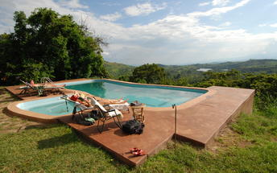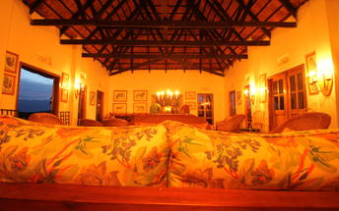

### Alternate: Kyaninga Lodge

Set against the stunning backdrop of Lake Kyaninga and the Rwenzori Mountains beyond, Kyaninga Lodge is the spectacular result of one man’s vision and six years of unwavering commitment to creating an experience of Africa’s beauty unlike anything else.

You can experience the beauty and romance of this unexplored region, while staying in the height of luxury and elegance. Nine exclusive cottages made from hand carved logs, superb dining, and a wealth of adventures await.The Kyaninga Team is looking forward to welcoming you to Kyaninga Lodge and helping you explore this remarkable region of Africa.

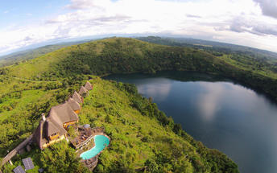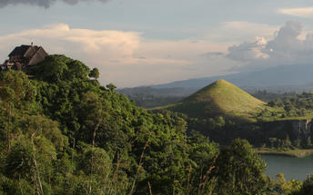

### Alternate: Turaco Treetops

Turaco Treetops is ideally located just outside the lush Kibale National Park, Uganda, where many birds, monkeys and butterflies that inhabit the Kibale Forest can also be found. The accommodation is in the form of cottages and rooms equipped with practical furniture, mosquito nets, comfortable beds, a private bathroom and a balcony with fantastic views over the canopy. Guests can enjoy all their meals in the main lodge's dining room or sit in the bar with a refreshing drink. Additional amenities and services include a swimming pool, a lounge area with a fireplace, a first-floor lounge with spectacular views over the forest and the snow-capped Rwenzori mountains and Wi-Fi. Guests can enjoy going on day/night forest walks, mountain bike tours and experience chimpanzee trekking.

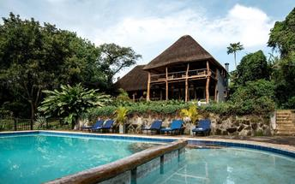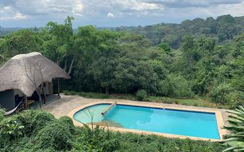

### Activities

|  |  |
| --- | --- |
| Afternoon | Crate walk tour |

### Basis

Full Board - Dinner, Bed, Breakfast and Lunch

## Day 2: Ndali Lodge, Kibale Forest National Park

### Day Itinerary

* 0700: Transfer to the park headquarters for your Chimpanzee briefing.
* 0800: Start the **Chimpanzee trekking in Kibale Forest.**
* 1230: Lunch
* 1330: Drive to Queen Elizabeth National Park
* 1500: Afternoon **Bigodi Wetland Sanctuary Visit.**
* 1930: Dinner and overnight stay at your lodge.

### Activities

|  |  |
| --- | --- |
| Morning | Kibale Forest Chimp Tracking |
| Afternoon | Bigodi Wetland Sanctuary |

#### Kibale Forest Chimp Tracking

The most favourite of Kibale’s walks embarks on from the Kanyanchu Visitor center at 08.00 & 15.00 and lasts 2 to 3 hours. Chimpanzee are the most sought after primate by visitors, but you should look out for the black & white colobus, red tailed monkey or the grey cheeked mangabey. Your guides will be able to show you pittas & different bird species and will give details of the tradit of the plant species within the forest. This walk is for 6 people in a group.

#### Bigodi Wetland Sanctuary

The Bigodi Wetland Sanctuary is a community development enterprise located on the fringe of Kibale National Park where guided tours are conducted along a path through the wetland at time along boardwalk trail. Bigodi is a birder's paradise with 138 bird species having been identified there including the crowd please Great Blue Turaco. The sanctuary is also home to 8 primate species including the black and white colobus, red colobus, mangabey, red tail, vervet, and L’Hoest.

### Basis

Full Board - Dinner, Bed, Breakfast and Lunch

## Day 3: End of Itinerary

### Day Itinerary

•    0800: Begin the day with a morning cup of coffee.  
•    0900: Drive and return to Kampala at your convenience.   
•    1230: Lunch enroute   
•    1400:Continue your journey to Kampala and Entebbe.   
•    1700: Esr=timated time to arrive and check-in   
•    TBA: Flight departure time to be advised.

### Basis

Bed and Breakfast

# Transport

## Transfers

|  |  |  |  |  |  |
| --- | --- | --- | --- | --- | --- |
| **Date** | **Company** | **Pick Up** | **Drop Off** | **Time** | **Vehicle** |
|  |  | Entebbe International Airport [EBB] | Ndali Lodge |  | Transfer |
|  |  | Ndali Lodge | Entebbe International Airport [EBB] |  | Transfer |