# 3 Days Gorilla Trekking Safari in Bwindi

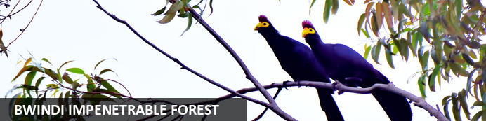

# 3 Days Gorilla Trekking Safari in Bwindi

*Bwindi Impenetrable Forest*  
*3 Days / 2 Nights*  
*0 Persons*  
*Date of Issue: 19 September 2023*

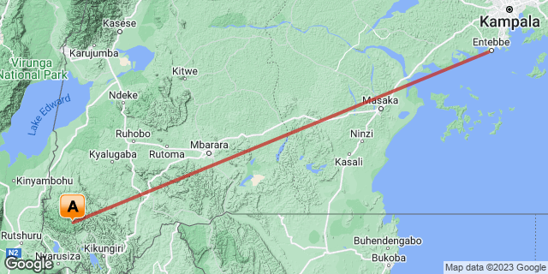

## Introduction

|  |  |  |  |  |  |
| --- | --- | --- | --- | --- | --- |
| **Start** | **Accommodation** | **Type** | **Destination** | **Basis** | **Duration** |
| Day 1 | Sanctuary Gorilla Forest Camp |  | Bwindi Impenetrable Forest | FB | **2 Nights** |
|  | → Buhoma Lodge | alternate |  |  |  |
|  | → Mahogany Springs Lodge | alternate |  |  |  |

**Key**  
B&B: Bed and Breakfast  
FB: Full Board - Dinner, Bed, Breakfast and Lunch

## Included

* Airport Transfers
* Ground transfers by 4 WD Safari Land Cruiser on safari in Bwindi.
* Return Flight fare Entebbe -Bwindi
* Community visit/Batwa Village Visit.
* One Gorilla permit for trekking  per person
* Services of an English-speaking guide- per vehicle.
* Fuel expenses.
* All accommodations and all meals while on the entire safari stay in Uganda.
* Meals (Breakfast, Lunch, and Dinner) while on safari
* 1 soft drink per meal i.e. a soda or mineral water at/during lunch and dinner,
* Park entrance fees.
* Bottled drinking water.
* Ranger fees.
* All government taxes.
* Our assistance.

## Excluded

* International flights,
* Personal Travel insurance,
* Visa Fees,
* Premium drinks,
* Cigarettes,
* Tips, souvenirs, and any other items of personal nature.

## Day 1: Sanctuary Gorilla Forest Camp, Bwindi Impenetrable Forest

### Bwindi Impenetrable Forest

Located in southwestern Uganda, the Bwindi Impenetrable Forest is said to be Africa’s oldest rainforest. It is world-renowned for its excellent gorilla-sighting opportunities - the forest is home to half of the remaining mountain gorillas on earth. This gorilla experience takes place among a rugged landscape of dense jungle, cascading waterfalls, sparkling mountain streams, deep valleys, and steep ridges. The untouched forest has been declared a UNESCO World Heritage Site for its breathtaking natural beauty and unique ecological significance, and aside from the amazing gorilla interactions, there are other drawcards such as a network of forest walks, over 340 species of bird to spot, and a variety of brightly-coloured butterflies to identify. Don’t miss the opportunity to explore the spectacular Virunga Volcanoes, three of which are still active.

### Day Itinerary

* 0900: Transfer to Entebbe International Airport
* 1015: Flight to Kihihi Airstrip.
* 1125: Estimated time of arrival at Kihihi Airstrip.
* 1140: Transfer to your lodge.
* 1300: Arrival and Lunch at the Lodge.
* 1500: Afternoon **Batwa Cultural Experience.**
* 1800: Dinner and overnight stay at your lodge.

### Overnight: Sanctuary Gorilla Forest Camp

Once-in-a-lifetime encounters with Uganda’s endangered gorillas await when you stay in one of these ten private luxury tents in the heart of the Bwindi Impenetrable Forest.

Ecologically respectful, contemporary-yet-classic in style, Sanctuary Gorilla Forest Camp blends in sensitively with the dramatic African mountain landscape and, situated uniquely inside the national park, you are only minutes away from the start of your gorilla trekking adventure.

Located in one of the remotest areas of Africa, these comfortable canvas spaces are dressed with indigenous prints and furniture made from natural materials. Beds are draped in neutral-toned linens, and local artefacts set a scene that ensures memorable moments both inside and out the accommodation. Each tent has a spacious, stone-walled bathroom with private sections, and a free-standing bath for a relaxing soak after a day’s trekking. The trees around the camp light up in the morning when the sun starts shining, and thanks to there being so few tents, the camp retains an intimate, exclusive feel, enabling you to experience Africa’s magic with the lightest of footprints yet with practically every mod con.

### Alternate: Buhoma Lodge

Nestled at the gateway to Bwindi Impenetrable Forest, Buhoma Lodge is one of only two lodges set within the national park, and is the perfect lodge of choice when embarking on your bucket-list Gorilla trekking adventure.

Renowned for its warm welcome and attentive service, guests love the homely ambience of this Africa inspired lodge. Constructed using sustainable materials, the elevated central lounge, bar and dining area (serving delicious multi-course meals) offers a cosy spot for guests to unwind, and offers amazing uninterrupted views over the forest. The crackling fireplace adds a mystical atmosphere to cooler evenings.

Tranquil and cosy, the ten spacious eco-friendly wooden chalets offer a private escape. Fall asleep to the sounds of the forest and awaken to chattering birds and monkeys as day breaks. Enjoy morning tea/coffee on your private veranda with sweeping views over the primal forest– what better way to start the day.

With Buhoma set just steps away from the trek start point, gorillas have been spotted popping in for an occasional visit, while our resident L'Hoest's monkey troup visit the gardens in front of the lodge almost daily, much to the delight of our guests.

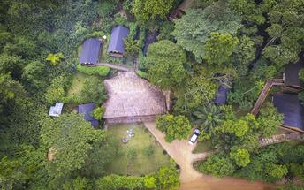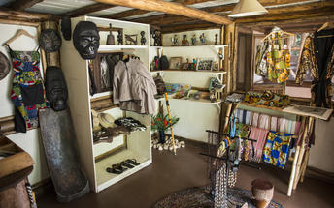

### Alternate: Mahogany Springs Lodge

Mahogany Springs is situated in one of the most intimate, secluded, beautiful and most importantly natural settings in the world and only around 2 minutes away from the Gorilla tracking starting point.

All the rooms at Mahogany Springs are high end suites. All Suites can be twin, double or triple. There is 24/7 power in all the rooms. All rooms have large en-suite bathrooms with a gorgeously designed open terracotta shower.

All 12 luxurious suites have their own private terrace with magnificent panoramic views over the grounds, river and surrounding areas.

The main dining area is exquisitely furnished and with panoramic views beyond the lodge’s own gardens you will enjoy dining in a tranquil and unrivalled setting. The service provided is as much an art form as the food therefore, the staff are trained to very high standards. Within the main building there is a stunning bar where guests can sit all day and night trying one of the many cocktails or simply a bottle of fine wine. Most of the produce used at Mahogany Springs is grown on site to provide guests with the freshest ingredients.

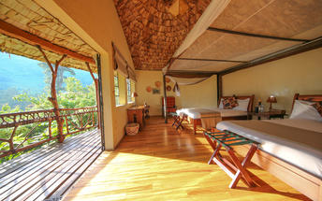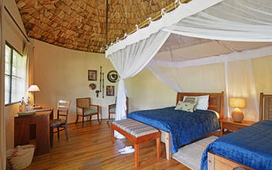

### Activities

|  |
| --- |
| Batwa Cultural Village |

#### Batwa Cultural Village

The Batwa Cultural village is where the Batwa (Pigmies) still live in the same way they used to years ago in tree houses. The Batwa only began leaving their forest homes around 15 years ago and they have been able to remain on this land thanks to the support of a generous American benefactor who donated the land back to them and created a cultural program. The fees from visiting tourists and are given to the Batwa project and they delight in welcoming visitors to their village and demonstrating how they make weapons, dance, make fires using sticks and cook.

### Basis

Full Board - Dinner, Bed, Breakfast and Lunch

## Day 2: Sanctuary Gorilla Forest Camp, Bwindi Impenetrable Forest

### Day Itinerary

* 0600: Start the day with morning breakfast ready for the day's gorilla trek
* 0700: Transfer/walk down to the park headquarters for the gorilla trek
* 0800: Start the **gorilla trekking adventure in Bwindi.**
* 1300: Estimated time of returning from the jungle.
* 1500: Afternoon **relaxation at your lodge.**
* 1830: Dinner is served at the Lodge.

### Activities

|  |
| --- |
| Gorilla Trekking Bwindi Impenetrable Forest |

#### Gorilla Trekking Bwindi Impenetrable Forest

Wake early for a hearty breakfast to give you the energy needed for gorilla trekking. Before 8:00 am, report to the ranger station for registration and a talk by one of the rangers. The guides will then take you through the bush, pushing your way through the undergrowth, to track the gorillas. (Please note this trek can take from 30 minutes to 5-6 hours). A reasonable degree of fitness is required, as well as a sturdy pair of walking shoes. Sit in the forest among the gorillas, listening to them ‘talk’ to one another, and marvel at the sheer size of the dominant male, the Silverback. It is an extraordinary feeling sitting in the dense rainforest knowing you are with a few of the last remaining mountain gorillas. It's amazing to think there are only about 650 of these beautiful creatures left.

### Basis

Full Board - Dinner, Bed, Breakfast and Lunch

## Day 3: End of Itinerary

### Day Itinerary

* 0700: Breakfast is served.
* 0800:Transfer to the Airstrip for your flight back to Entebbe.
* 0945: The flight departs Kihihi-Entebbe.
* 1125: Estimated time of arrival at Entebbe Airport for your outbound international flight.
* End of service.

### Basis

Bed and Breakfast

# Transport

## Flight Information

|  |  |  |  |  |  |  |  |  |
| --- | --- | --- | --- | --- | --- | --- | --- | --- |
| **Date** | **Flight** | **Airline** | **Departure Airport** | **Time** | **Arrival Airport** | **Time** | **Class** | **Ref** |
|  | Scheduled |  | Entebbe International Airport [EBB] |  | Sanctuary Gorilla Forest Camp |  |  |  |
|  | Scheduled |  | Sanctuary Gorilla Forest Camp |  | Entebbe International Airport [EBB] |  |  |  |