

# 3 Days Murchison Falls National Park Safari

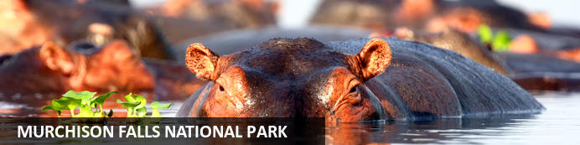

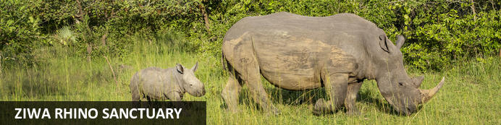

# 3 Days Murchison Falls National Park Safari

*Murchison Falls National Park - Ziwa Rhino Sanctuary*  
*3 Days / 2 Nights*  
*0 Persons*  
*Date of Issue: 19 September 2023*

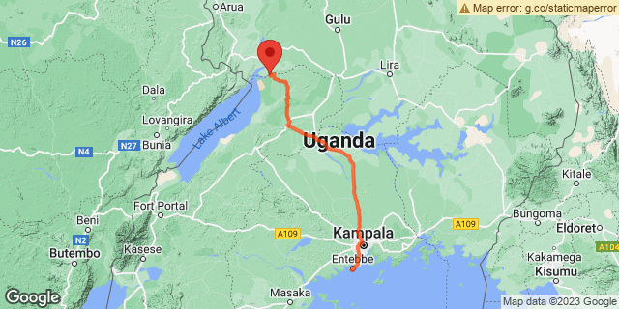

## Introduction

|  |  |  |  |  |  |  |
| --- | --- | --- | --- | --- | --- | --- |
| **Start** | **Accommodation** | **Type** | **Destination** | **Basis** | **Room Type** | **Duration** |
| Day 1 | Nile Safari Lodge |  | Murchison Falls National Park | FB | 1x Deluxe room | **2 Nights** |
|  | → Paraa Safari Lodge | alternate |  |  |  |  |
|  | → Murchison River Lodge | alternate |  |  |  |  |

**Key**  
B&B: Bed and Breakfast  
FB: Full Board - Dinner, Bed, Breakfast and Lunch

## Included

•    Airport transfers.  
•    Exclusive use of private 4x4 Safari Land cruiser  
•    Accommodation and meals as per the itinerary   
•    Boat trip in Murchison Falls National Park  
•    Visit the top of the falls  
•    Park fees.  
•    Ziwa Sanctuary Rhino Tour.  
•    Services of English-speaking Driver/guide.  
•    Enroute lunches.  
•    All Game drives.  
•    Bottled drinking water.   
•    All our assistance.   
•    All government taxes.

## Excluded

* International and domestic airline tickets unless indicated,
* All extra activities, visits, entrances, and extra meals/drinks not  mentioned in the itinerary
* Entry visa fees,
* Optional extras whilst in Uganda
* Drinks throughout the trip,
* Tips and gratuities,
* Personal expenses such as telephone calls, mini bar, porter-age, travel insurance, etc.

## Day 1: Nile Safari Lodge, Murchison Falls National Park

### Murchison Falls National Park

Stretching from the shores of Lake Albert, Murchison Falls National Park is Uganda's largest National Park. The Nile River flows through the middle of the park creating the impressive Murchison Falls which is the park’s major attraction. The landscape features dense rainforest, undulating savannah and a diversity of abundant wildlife. Visitors can enjoy prime game-viewing along the Buligi Circuit. The forests are home to numerous primates, including Chimpanzees, and near the river, buffalo, elephants and Rothschild-Giraffes can be seen. Other commonly spotted wildlife include: lions, antelope, waterbucks, hippos and crocodiles.

### Day Itinerary

•          0700: Begin the day with breakfast.  
•          0800: Drive to Murchison Falls   
•          1100: Visit Ziwa Rhino Sanctuary for Rhino trekking  
•          1330: Lunch at the Sanctuary  
•          1530: Continue to Murchison Falls  
•          1800: Estimated time to arrive at the park.   
•          1930: Dinner and overnight stay.

### Overnight: Nile Safari Lodge

Nile Safari Lodge is a luxury eco-friendly safari lodge located on the Victoria Nile River banks in Uganda. The lodge is situated in the heart of the Murchison Falls National Park and offers spectacular views of the river and endless game viewing opportunities. Accommodation includes eight secluded bandas equipped with en-suite facilities, a private view deck with deck chairs and a mosquito net. Guests may enjoy delicious meals at the on-site restaurant.

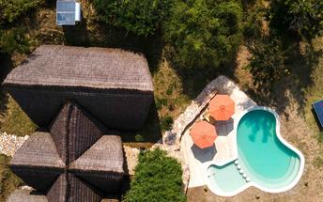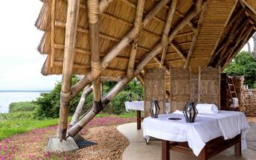

### Alternate: Paraa Safari Lodge

Paraa Safari Lodge is situated in Murchison Falls National Park, northwest Uganda. It overlooks nature's best-kept secrets, the River Nile, on its journey from its source at Lake Victoria. The lodge accommodation options include cottages, suites, double, twin and single rooms featuring fans, balconies and en-suite bathrooms. During their stay, guests can enjoy delicious local and international specialities at the on-site restaurant. Leisure facilities include a swimming pool, bar and a gift shop.

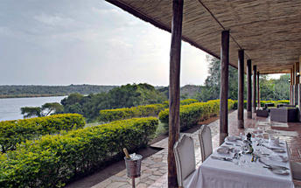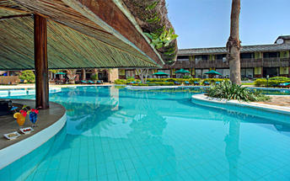

### Alternate: Murchison River Lodge

Murchison River Lodge sits on the southern bank of the River Nile overlooking Uganda’s Murchison Falls National Park. In beautiful surroundings, the property offers comfortable and relaxing mid-range accommodation to suit all budgets in attractive thatched cottages, riverside safari tents and simple camping tents.

Guests can explore the Murchison Falls National Park. One of Uganda’s largest national parks. Guests can relax and unwind at the lodge with a pair of binoculars and guide book or experience a safari and boat trip along the Nile.

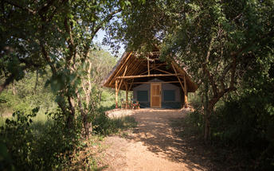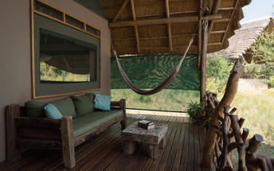

### Activities

|  |
| --- |
| Ziwa Rhino Sanctuary |

#### Ziwa Rhino Sanctuary

Located north of Kampala in the Nakasongola district of Uganda, The Ziwa Rhino Sanctuary is the only place in the country with wild rhinos. Currently home to twenty two southern white rhinos, the sanctuary offers rhino trekking, shoebill trekking, canoeing, bird watching, and night walks. Visitors may also spot a range of other species including Uganda kobs, oribis, bush bucks, and water bucks. The prehistoric-looking shoebill stork is one of the most sought after birds in Uganda, and the sanctuary is one of the only places where they can almost always be seen. See over 300 bird species along bird trails through the woodlands, swamp and savannah, and take a guided night walk, where you will be introduced to extraordinary night sounds and sensations, including a beautifully clear night sky and several nocturnal animals.

### Basis

Full Board - Dinner, Bed, Breakfast and Lunch

## Day 2: Nile Safari Lodge, Murchison Falls National Park

### Day Itinerary

•    0600: Begin the day with a cup of coffee.  
•    0615: Start off your dawn **Murchison game safari drive.**      
•    0900: Return from your game drive for a full breakfast and refreshments.  
•    1200: Lunch at the Lodge  
•    1330: Transfer to catch up a boat ride along the Nile at 14h00.   
•    1400: Proceed for 3hrs **Murchison Falls boat safari.**  
•    1700: Return to the lodge.   
•    1830: Dinner and overnight stay at your lodge.

### Activities

|  |
| --- |
| Murchison Falls National Park Game Drive |
| Murchison Falls Boat Trip |

#### Murchison Falls National Park Game Drive

The Murchison Falls National Park Game Drive takes place in the Murchison Falls National Park. The main areas of the drive are the Delta, Buligi Peninsula and the southern section which is known as the heart of Murchison. The Delta allows visitors an opportunity to see Lions, while the triangle of grassland in the Buligi Peninsula provides an opportunity to see elephant, buffalo, antelopes, and giraffes. This grassland is bound by the Victoria Nile entering Lake Albert with the Albert Nile flowing out of it. Lions, leopard, and waterbirds along with hippos can also be spotted here. Much of the southern part is populated with dense bush and forest, where lions and giraffes can also be seen.

#### Murchison Falls Boat Trip

Launches run from Paraa to the base of the Falls. The three hour return journey is for many a highlight of a trip to Murchison. Along the river there are thousands of hippos, enormous crocodiles, amazing bird life a possible sighting of the rare shoebill.

A boat trip from Paraa to the Delta where the Victoria Nile enters Lake Albert offers excellent game viewing and birding opportunities and takes about five hours.

### Basis

Full Board - Dinner, Bed, Breakfast and Lunch

## Day 3: End of Itinerary

### Day Itinerary

•    0700: Begin the day with a cup of coffee.  
•    0800: Visit the top of the falls.  
•    1000: Return to Kampala with Lunch enroute.   
•    1700: Estimated time of arrival in Kampala.   
•    0000: Flight time to be advised.   
•    End of service.

### Activities

|  |
| --- |
| Murchison Falls Top of the Falls Walk |

#### Murchison Falls Top of the Falls Walk

Some of the most powerful moving water in the world, the top of Murchison Falls sees the entirety of the Nile River squeeze itself through a mere 7-meter gap; an epic display of nature’s power. A trail runs down the side of the gorge, allowing the opportunity to view the main falls, and the second “Independence” falls. The views are spectacular and the spray of the falls really refreshing. The walk takes approximately 45 minutes and requires average fitness.

### Basis

Breakfast and Lunch

# Transport

## Transfers

|  |  |  |  |  |  |
| --- | --- | --- | --- | --- | --- |
| **Date** | **Company** | **Pick Up** | **Drop Off** | **Time** | **Vehicle** |
|  |  | Entebbe International Airport [EBB] | Nile Safari Lodge |  | Transfer |
|  |  | Nile Safari Lodge | Entebbe International Airport [EBB] |  | Transfer |