

# 4 Days Uganda Safari to Kidepo Valley National Park

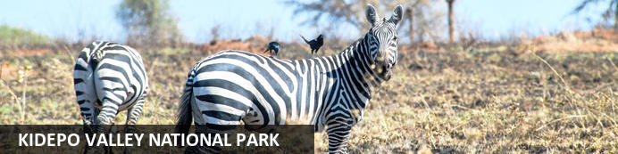

# 4 Days Uganda Safari to Kidepo Valley National Park

*Kidepo Valley National Park*  
*4 Days / 3 Nights*  
*0 Persons*  
*Date of Issue: 22 September 2023*

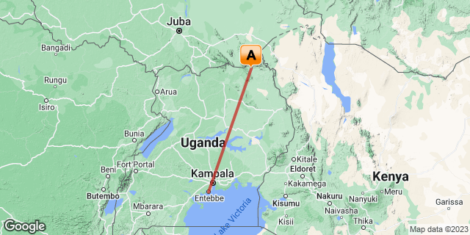

## Introduction

|  |  |  |  |  |  |
| --- | --- | --- | --- | --- | --- |
| **Start** | **Accommodation** | **Type** | **Destination** | **Basis** | **Duration** |
| Day 1 | Apoka Safari Lodge |  | Kidepo Valley National Park | FB | **3 Nights** |
|  | → Kidepo Savannah Lodge | alternate |  |  |  |

**Key**  
B&B: Bed and Breakfast  
FB: Full Board - Dinner, Bed, Breakfast and Lunch

## Included

* Airport transfers
* Return Flight fares
* Accommodation and meals as per the itinerary
* Park entrance fees.
* All ground transfers
* Game drives
* Nature walk
* Guides fees
* Cultural visit
* Bottled drinking water
* Our assistance

## Excluded

* International flights,
* Personal Travel insurance,
* Visa Fees,
* Premium drinks,
* Cigarettes,
* Tips, souvenirs, and any other items of personal nature.

## Day 1: Apoka Safari Lodge, Kidepo Valley National Park

### Kidepo Valley National Park

One of Uganda’s most stunningly beautiful reserves, the remote Kidepo Valley National Park stretches across the Karamoja region of northeast Uganda. Broad swathes of savannah are studded with hills and rock clusters, traversed by the forest-flanked Lorupei River. The park is home to roughly 80 mammal species, 28 of which are found at no other park in the country, and is particularly well known for its rich population of raptors, as well as over 450 species of bird. Visitors can look forward to excellent wildlife sightings including greater and lesser kudu, eland, lion, leopard, cheetah, elephant, and a variety of plains game.

### Day Itinerary

* 1000: Pick up and transfer to Entebbe Airport for your flight.
* 1245: Flight departs at Kidepo
* 1445: Flight arrives at Kidepo
* 1500: Pick up from the airstrip and check in to your lodge.
* 1​600: Begin your evening **Kidepo game drive**.
* 1900: Return for dinner and overnight stay.

### Overnight: Apoka Safari Lodge

Set deep in the Kidepo Valley National Park, Apoka Lodge blends seamlessly among the endless hills and rocky outcrops. With only 10 guest rooms, this is intimate and remote at its best.

Kidepo is Uganda's most isolated National Park, located in the northern reaches of the country where the light is golden, the wildlife abundant and the skies are enormous. Elephants roam through the camp, lions perch on the nearby boulders as if posing for their close-up, and massive herds of buffalo are a part of the landscape.

Apoka lodge is built in the traditional manner: canvas-walled rooms with high thatched roofs and big breezy windows open to the views. All rooms feature private outdoor bathtubs - deep tubs surrounded by big boulders - looking out over the landscape. The decor is neutral and natural: a palette of cream, stone and oatmeal allows the impressive scenery to take precedence and a massive rock-hewn pool brings respite to the hot sunny afternoons.

Guides, all from the local area, lead activities including walks, game drives in open vehicles and interpretive visits to the local Karamong villages or the secluded homestead of the fascinating hunter-gatherer Ik people.

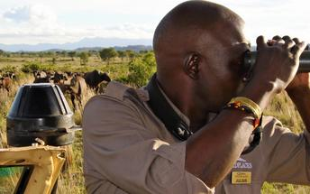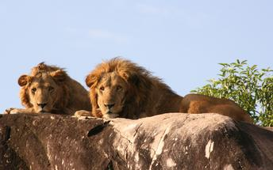

### Alternate: Kidepo Savannah Lodge

On the edge of one of the most beautiful National Parks in Uganda lies Kidepo Savannah Lodge. The lodge is inspired by the Savannah surroundings, the grasslands, rocky outcrops, and by the Karamajong tribe with their manyattas and colourful blankets. The accommodation consists of luxurious self contained safari tents and comfortable lazy camping tents. Activities available for guests to enjoy include game drives, and nature walks visiting the Lamoj Mountains and Kidepo River Valley.

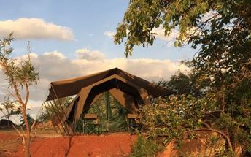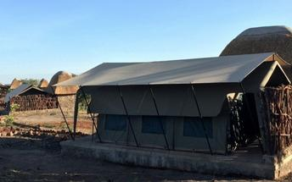

### Activities

|  |
| --- |
| Kidepo Valley National Park Game Viewing Safari |

#### Kidepo Valley National Park Game Viewing Safari

Kidepo Valley National Park Game Viewing Safari provides guests with an opportunity to see some of the large collections of mammal species residing in the national park, including greater Kudu, Chandler's Mountain reedbuck, elephant and bush pig to name a few. The game viewing safaris explore the Kidepo valley that has astounding landscapes and magical sceneries. The area is dry most part of the year, most mammals shift to areas with water and fresh pasture.

### Basis

Full Board - Dinner, Bed, Breakfast and Lunch

## Day 2: Apoka Safari Lodge, Kidepo Valley National Park

### Day Itinerary

* 0​600: Morning breakfast
* 0​630: Begin your morning **Kidepo game drive**.
* 1300: Lunch at the Lodge.
* 1500: Cultural Visit of the **Karamajongs & Ik people**
* 1800: Return for dinner and overnight stay.

### Activities

|  |
| --- |
| Kidepo Valley National Park Game Viewing Safari |
| Kidepo Cultural visit |

#### Kidepo Valley National Park Game Viewing Safari

Kidepo Valley National Park Game Viewing Safari provides guests with an opportunity to see some of the large collections of mammal species residing in the national park, including greater Kudu, Chandler's Mountain reedbuck, elephant and bush pig to name a few. The game viewing safaris explore the Kidepo valley that has astounding landscapes and magical sceneries. The area is dry most part of the year, most mammals shift to areas with water and fresh pasture.

### Basis

Full Board - Dinner, Bed, Breakfast and Lunch

## Day 3: Apoka Safari Lodge, Kidepo Valley National Park

### Day Itinerary

* 0​700: Morning breakfast.
* 0​830: Begin your morning**guided nature walk.**
* 1300: Lunch at the Lodge.
* 1​600: Embark on an **evening game drive in Kidepo.**
* 1800: Return for dinner and overnight stay.

### Activities

|  |
| --- |
| Kidepo guided nature walk |
| Kidepo Valley National Park Game Viewing Safari |

#### Kidepo Valley National Park Game Viewing Safari

Kidepo Valley National Park Game Viewing Safari provides guests with an opportunity to see some of the large collections of mammal species residing in the national park, including greater Kudu, Chandler's Mountain reedbuck, elephant and bush pig to name a few. The game viewing safaris explore the Kidepo valley that has astounding landscapes and magical sceneries. The area is dry most part of the year, most mammals shift to areas with water and fresh pasture.

### Basis

Full Board - Dinner, Bed, Breakfast and Lunch

## Day 4: End of Itinerary

### Day Itinerary

* 0​700: Morning breakfast.
* 0​830: Drive and visit Katurum Lodge.
* 1300: Lunch at the Lodge.
* 1430: Transfer to the airstrip.
* 1​500: Fly back to Entebbe
* 1​​630: Estimated time of arrival at Entebbe Airport.
* 1700: End of service.

### Basis

Bed and Breakfast

# Transport

## Flight Information

|  |  |  |  |  |  |  |  |  |
| --- | --- | --- | --- | --- | --- | --- | --- | --- |
| **Date** | **Flight** | **Airline** | **Departure Airport** | **Time** | **Arrival Airport** | **Time** | **Class** | **Ref** |
|  | Scheduled |  | Entebbe International Airport [EBB] |  | Apoka Safari Lodge |  |  |  |
|  | Scheduled |  | Apoka Safari Lodge |  | Entebbe International Airport [EBB] |  |  |  |