

# 3 Days Golden Monkey Tracking in Rwanda

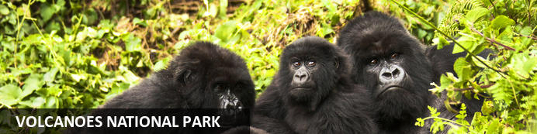

# 3 Days Golden Monkey Tracking in Rwanda

*Volcanoes National Park*  
*3 Days / 2 Nights*  
*0 Persons*  
*Date of Issue: 05 October 2023*

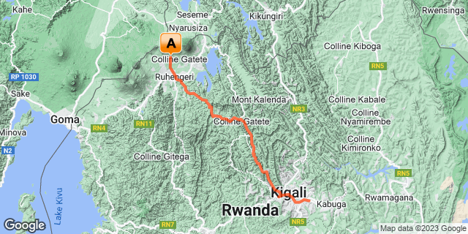

## Introduction

|  |  |  |  |  |  |
| --- | --- | --- | --- | --- | --- |
| **Start** | **Accommodation** | **Type** | **Destination** | **Basis** | **Duration** |
| Day 1 | Singita Kwitonda Lodge |  | Volcanoes National Park | FB | **2 Nights** |
|  | → Virunga Inn Resort & Spa | alternate |  |  |  |

**Key**  
B&B: Bed and Breakfast  
FB: Full Board - Dinner, Bed, Breakfast and Lunch

## Included

• Airport and inter-hotel transfers from day 1 to the last day.  
•    All activities as highlighted in the itinerary.   
•    2 Nights at Volcanoes National Park.  
•    1 Golden Monkey permit per person (this includes briefing at RDB offices, guide, and trek – US$ 100.-)  
• Exclusive use of a private safari land cruiser  4x4 with WI-FI in receptive areas.   
•Services of a professional, experienced English-speaking driver guide.  
•Village/ Cultural Visit to Volcanoes.  
•Bottled mineral water in the vehicle during the tour.  
• All government taxes.  
•Our assistance.

## Excluded

* International and domestic airline tickets unless indicated,
* All extra activities, visits, entrances, and extra meals/drinks are not mentioned in the itinerary.
* Entry visa fees,
* Optional extras whilst in Kigali.
* Drinks throughout the trip,
* Tips and gratuities,
* Personal expenses such as telephone calls, mini bar, porter-age, travel insurance, etc.

## Day 1: Singita Kwitonda Lodge, Volcanoes National Park

### Volcanoes National Park

Bordering the Democratic Republic of Congo in Rwanda, and set high on the jungle-covered slopes of the volcanic Virunga Mountains, the Volcanoes National Park is best known as a sanctuary for the region’s rare mountain gorillas. Visitors flock here to experience face to face encounters with these intriguing creatures. Regulated treks through the reserve allow visitors to spend an hour at a time with these incredible primates in their natural habitat. While the gorillas are without a doubt the main drawcard, visitors can also look forward to exploring a network of scenic hiking trails, with the beautiful day hike to the crater lake on Mount Bisoke being a particular highlight. Make sure to visit the fascinating Karisoke Research Centre and the tomb of the world-famous Dian Fossey.

### Day Itinerary

* 1000: BEstimated time of arriving at Kigali International Airport.
* 103000: Transfer to Volcanoes National Park
* 1300: Estimated time of arrival.
* 13150: Lunch at the lodge.
* 1500: Rest of the day relaxation at the lodge.
* 1800: Dinner and overnight stay at your lodge.

### Overnight: Singita Kwitonda Lodge

Boasting breathtaking views of the Sabyinyo, Gahinga and Muhabura volcanoes and surrounded by high-altitude forests, Singita Kwitonda Lodge offers an experience unlike any of Singita’s other destinations. With its exceptional natural beauty, environmentally conscious luxury and transformative, purpose-driven experiences, the lodge was designed in response to this remarkable location, and the eight contemporary suites (as well as the private four-bedroom villa – Kataza House) are linked by volcanic rock pathways to the central lodge.

The interiors emphasise local design and handcrafted details adorn the carefully planned spaces. Layered textures and colours enhance the reflective quality of this tranquil haven and an experiential enclave offers free-flowing indoor and outdoor areas. A convivial fire pit, interactive kitchen, bar-deli and wine cellar complete the picture.

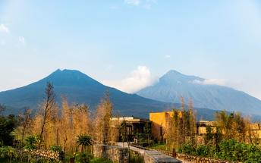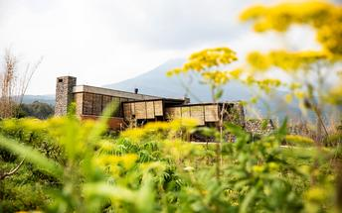

### Alternate: Virunga Inn Resort & Spa

Located in Kinigi, Rwanda, Virunga Inn Resort & Spa offers stylish accommodations with beautiful views of the mountains. The property features beautifully appointed rooms equipped with comfortable bedding, a private bathroom, a flat-screen TV, a safety deposit box, and a seating area. The property also features a 24-hour front desk, free Wi-Fi throughout, room service, and a restaurant serving a tasty breakfast each morning.

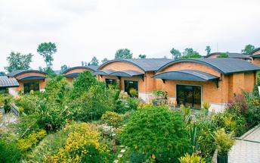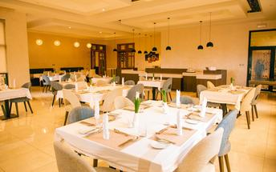

### Basis

Full Board - Dinner, Bed, Breakfast and Lunch

## Day 2: Singita Kwitonda Lodge, Volcanoes National Park

### Day Itinerary

* 0600: Begin the day with a morning breakfast.
* 0630: Transfer to the park headquarters for Golden Monkey trekking briefing.
* 0800: Start the Golden Monkey trekking in**Volcanoes National Park.**
* 1200: Estimated time of returning from the jungle.
* 1230: Transfer back to the Lodge.
* 1300: Lunch at the Lodge.
* 1500: Afternoon **Iby Wacu Cultural Village**
* 1800: Dinner and overnight stay at your lodge.

### Activities

|  |
| --- |
| RDB Golden Monkey Tracking |
| Iby'Iwacu Cultural Village |

#### RDB Golden Monkey Tracking

Located in Volcanoes National Park, Rwanda, RDB Golden Monkey Tracking offers visitors a unique experience of catching a glimpse of the endangered Golden Monkey. These striking primates with their bright orange fur contrasting the green rainforests of the Virunga Mountains is a photographers dream. The Golden Monkey can be found in very few places outside of Volcanoes National Park, and their vibrant colours, energetic demeanour, and sizeable troupes of up to 30 individuals are indeed a sight to behold.

#### Iby'Iwacu Cultural Village

Offering an adventurous stay in a traditional rural, Rwandan village that has existed for centuries living with and next to mountain gorillas in Parc National des Volcans. Iby’Iwacu Cultural Village gives you a rare chance to meet local people, in their environment, with a taste of our culture and traditions. The community you visit will genuinely welcome you as a special guest while they proudly present to you aspects of their traditions and beliefs. This will truly be an experience of a lifetime as you home stay with the community and become part of their family

### Basis

Full Board - Dinner, Bed, Breakfast and Lunch

## Day 3: End of Itinerary

### Day Itinerary

* 0800: Begin the day with a morning breakfast.
* 1000: Check out and return to Kigali
* 123: Lunch in Kigali
* 1430: T transfer to the airport for your flight back.
* TBA: Flight time to be advised.

### Basis

Breakfast and Lunch

# Transport

## Transfers

|  |  |  |  |  |  |
| --- | --- | --- | --- | --- | --- |
| **Date** | **Company** | **Pick Up** | **Drop Off** | **Time** | **Vehicle** |
|  |  | Kigali International Airport [KGL] | Singita Kwitonda Lodge |  | Transfer |
|  |  | Singita Kwitonda Lodge | Kigali International Airport [KGL] |  | Transfer |