

# 3 Days Hiking Mount Karisimbi in Rwanda

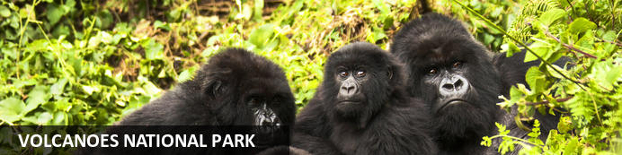

# 3 Days Hiking Mount Karisimbi in Rwanda

*Volcanoes National Park*  
*3 Days / 2 Nights*  
*0 Persons*  
*Date of Issue: 11 October 2023*

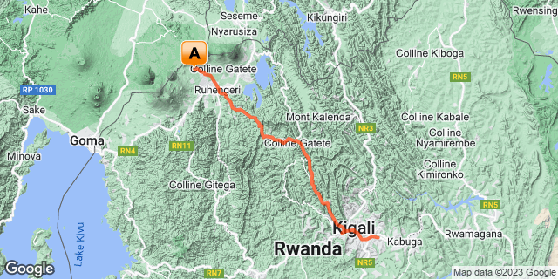

## Introduction

|  |  |  |  |  |  |
| --- | --- | --- | --- | --- | --- |
| **Start** | **Accommodation** | **Type** | **Destination** | **Basis** | **Duration** |
| Day 1 | Virunga Inn Resort & Spa |  | Volcanoes National Park | FB | **1 Nights** |
|  | → Five Volcanoes Boutique Hotel | alternate |  |  |  |

**Key**  
B&B: Bed and Breakfast  
FB: Full Board - Dinner, Bed, Breakfast and Lunch

## Included

• Airport and inter-hotel transfers from day 1 to the last day.  
•    All activities as highlighted in the itinerary.   
•    2 Nights at Volcanoes National Park.  
•    2 Days of hiking Mount Karismbi.   
• Exclusive use of a private safari land cruiser  4x4.   
•Services of a professional, experienced English-speaking driver guide.  
•1 Golden Monkey trek permit per person.   
•Bottled mineral water in the vehicle during the tour.  
• All government taxes.  
•Our assistance.

## Excluded

* International and domestic airline tickets unless indicated,
* All extra activities, visits, entrances, and extra meals/drinks are not mentioned in the itinerary.
* Entry visa fees,
* Optional extras whilst in Kigali.
* Drinks throughout the trip,
* Tips and gratuities,
* Personal expenses such as telephone calls, mini bar, porter-age, travel insurance, etc.

## Day 1: Volcanoes National Park

### Volcanoes National Park

Bordering the Democratic Republic of Congo in Rwanda, and set high on the jungle-covered slopes of the volcanic Virunga Mountains, the Volcanoes National Park is best known as a sanctuary for the region’s rare mountain gorillas. Visitors flock here to experience face to face encounters with these intriguing creatures. Regulated treks through the reserve allow visitors to spend an hour at a time with these incredible primates in their natural habitat. While the gorillas are without a doubt the main drawcard, visitors can also look forward to exploring a network of scenic hiking trails, with the beautiful day hike to the crater lake on Mount Bisoke being a particular highlight. Make sure to visit the fascinating Karisoke Research Centre and the tomb of the world-famous Dian Fossey.

### Day Itinerary

* 0430: Depart Kigali in the morning.
* 0440:Transfer to Volcanoes National Park
* 0700: Estimated time of arrival.
* 0730: Briefing for **Karismbi Mountain Hike.**
* 0800: Start the hike for a day.
* 1800: Overnight on the mountain.

### Activities

|  |
| --- |
| Karismbi Mountain Hike |

### Basis

Full Board - Dinner, Bed, Breakfast and Lunch

## Day 2: Virunga Inn Resort & Spa, Volcanoes National Park

### Day Itinerary

* 0700: Begin the day with a morning breakfast.
* 0730: Another day to descend from the Mountain
* 1500: Estimated time of arriving at the base camp.
* 1600: Transfer to your hotel for an overnight stay.
* 1800: Dinner at your lodge.

### Overnight: Virunga Inn Resort & Spa

Located in Kinigi, Rwanda, Virunga Inn Resort & Spa offers stylish accommodations with beautiful views of the mountains. The property features beautifully appointed rooms equipped with comfortable bedding, a private bathroom, a flat-screen TV, a safety deposit box, and a seating area. The property also features a 24-hour front desk, free Wi-Fi throughout, room service, and a restaurant serving a tasty breakfast each morning.

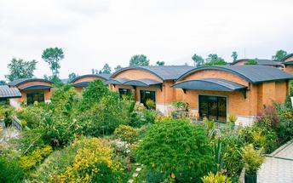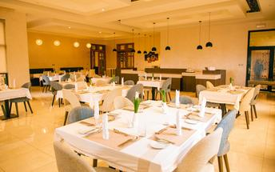

### Alternate: Five Volcanoes Boutique Hotel

Five Volcanoes Boutique Hotel in Musanze (Ruhengeri) located on the road going to Kinigi is a convenient starting point to go for different activities that the Volcanoes National Park is offering. Each of the rooms features hairdryers, flat-screen TVs, private bathrooms and mini-bars. A the hotel guests will find a restaurant, a pool, and a beautiful garden. 24-hour front desk service is also available as well as massage service.

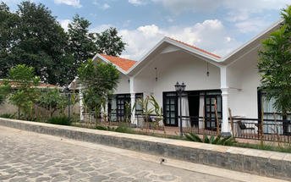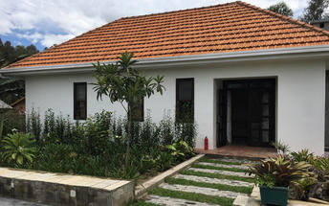

### Activities

|  |
| --- |
| Second day Hiking Karismbi |

### Basis

Full Board - Dinner, Bed, Breakfast and Lunch

## Day 3: End of Itinerary

### Day Itinerary

* 0600: Begin the day with a morning breakfast.
* 0630: Transfer to the park headquarters for Golden Monkey trekking briefing.
* 0800: Start the **golden monkey trekking in Volcanoes National Park.**
* 1200: Estimated time of returning from the jungle.
* 1230: Transfer back to the Lodge.
* 1400:Drive and return to Kigali
* 1630: Estimated time of arrival and transfer to the airport for your flight back.
* TBA: Flight time to be advised.

### Activities

|  |
| --- |
| Volcanoes National Park Golden Monkey Trekking |

#### Volcanoes National Park Golden Monkey Trekking

Volcanoes National Park in Rwanda offers Golden monkeys trekking. This unique experience allows guests in groups of up to eight to look for and discover golden monkeys within their natural habitat.

The monkeys are incredibly active and enjoy showing off for tourists and researchers that they encounter daily. The monkeys can be found closer to the base of the volcano and enjoy eating the bamboo vegetation in the area.

### Basis

Breakfast and Lunch

# Transport

## Transfers

|  |  |  |  |  |  |
| --- | --- | --- | --- | --- | --- |
| **Date** | **Company** | **Pick Up** | **Drop Off** | **Time** | **Vehicle** |
|  |  | Kigali International Airport [KGL] | Virunga Inn Resort & Spa |  | Transfer |
|  |  | Virunga Inn Resort & Spa | Kigali International Airport [KGL] |  | Transfer |