

# 3 Days Rwanda Tour to Volcanoes National Park

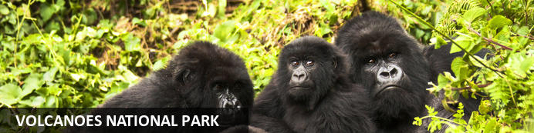

# 3 Days Rwanda Tour to Volcanoes National Park

*Volcanoes National Park*  
*3 Days / 2 Nights*  
*0 Persons*  
*Date of Issue: 11 October 2023*

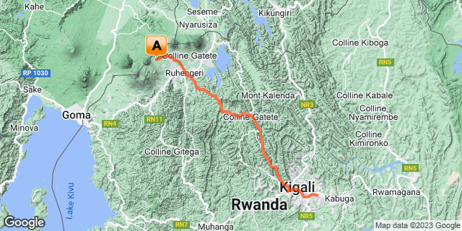

[**info@saltholidays.com**](mailto:info@saltholidays.com) **Website: https://www.saltholidays.com ; Cell: ​+256 700 999 111**

## Introduction

|  |  |  |  |  |  |
| --- | --- | --- | --- | --- | --- |
| **Start** | **Accommodation** | **Type** | **Destination** | **Basis** | **Duration** |
| Day 1 | Wilderness Bisate |  | Volcanoes National Park | FB | **2 Nights** |
|  | → Virunga Lodge | alternate |  |  |  |

**Key**  
B&B: Bed and Breakfast  
FB: Full Board - Dinner, Bed, Breakfast and Lunch

## Included

• Airport and inter-hotel transfers from day 1 to the last day.  
•    All activities as highlighted in the itinerary.   
•    2 Nights at Volcanoes National Park.  
•    1 Gorilla permit per person (this includes briefing at RDB offices, guide, and trek – US$ 1500.-)  
• Exclusive use of a private safari land cruiser  4x4   
•Services of a professional, experienced English-speaking driver guide.  
•Village/ Cultural Visit to Volcanoes.  
•Bottled mineral water in the vehicle during the tour.  
•All government taxes.   
•Our assistance.

## Excluded

* International and domestic airline tickets unless where indicated,
* **Visit Dian Fossey Gorilla Museum.**
* All extra activities, visits, entrances, and extra meals/drinks are not mentioned in the itinerary.
* Entry visa fees,
* Optional extras whilst in Kigali.
* Drinks throughout the trip,
* Tips and gratuities,
* Personal expenses such as telephone calls, mini bar, porter-age, travel insurance, etc.

## Day 1: Wilderness Bisate, Volcanoes National Park

### Volcanoes National Park

Bordering the Democratic Republic of Congo in Rwanda, and set high on the jungle-covered slopes of the volcanic Virunga Mountains, the Volcanoes National Park is best known as a sanctuary for the region’s rare mountain gorillas. Visitors flock here to experience face to face encounters with these intriguing creatures. Regulated treks through the reserve allow visitors to spend an hour at a time with these incredible primates in their natural habitat. While the gorillas are without a doubt the main drawcard, visitors can also look forward to exploring a network of scenic hiking trails, with the beautiful day hike to the crater lake on Mount Bisoke being a particular highlight. Make sure to visit the fascinating Karisoke Research Centre and the tomb of the world-famous Dian Fossey.

### Day Itinerary

* 0900: Pick up from Kigali International Airport
* 0915: Transfer to Volcanoes National Park
* 1230: Arrival at your lodge for your check-in.
* 1300: Lunch for the day.
* 1530: Afternoon relaxation at the Lodge.
* 1800: Dinner and overnight stay at your lodge.

### Overnight: Wilderness Bisate

Wilderness Bisate is located in the natural amphitheatre of an eroded volcanic cone and has dramatic views of the peaks of the volcanoes, Bisoke and Karisimbi, rearing up through the Afro-alpine forests of nearby Volcanoes National Park. Six luxurious en-suite Forest Villas maximise comfort and views, while retaining environmental principles and reflecting the culture of rural Rwanda. Each guest contributes to Bisate’s biodiversity conservation and local community projects – making a far-reaching impact on an iconic endangered species: the mountain gorilla.

Aside from tracking one of the several habituated gorilla groups, activities include visiting nearby natural attractions, hiking to Dian Fossey’s burial site, and observing the Park’s group of endangered endemic golden monkey. Walks on Bisate’s property offer birding and participation in the reforestation programme.

INSIDER’S TIP: Wilderness Bisate is within easy driving distance of Volcanoes National Park Headquarters, from where gorilla treks depart daily.

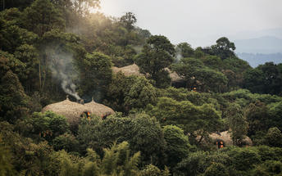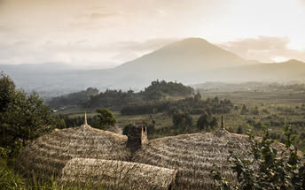

### Alternate: Virunga Lodge

The Original Gorilla Lodge in Rwanda

The magnificent Virunga Lodge in Rwanda is one of Africa’s most loved lodges. Perched high on a ridge with dramatic views overlooking the Virunga Volcanoes, Musanze valley, Lake Bulera and Lake Ruhondo.

The iconic property has defined Rwandese Afro-chic since the lodge was built by Praveen Moman in 2004. The timeless, hand-made style makes it the first accommodation choice for tracking the endangered mountain gorilla.

Exceptional hospitality, locally-inspired food and a private butler are hallmarks of the guest experience.

Each of the ten elegant bandas has a private terrace overlooking the dramatic landscape. The three deluxe bandas offer a private suite.

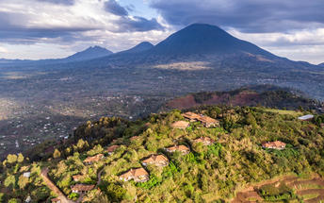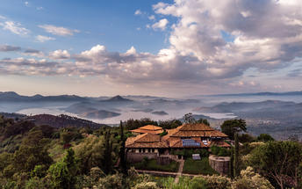

### Basis

Full Board - Dinner, Bed, Breakfast and Lunch

## Day 2: Wilderness Bisate, Volcanoes National Park

### Day Itinerary

* 0600: Breakfast and report to the park headquarters.
* 0800: Start the **gorilla trekking in Volcanoes National Park.**
* 1200: Estimated time of returning from the jungle.
* 1230: Lunch at a nearby facility before heading back to your lodge.
* 1500: Visit **Iby’ Iwacu cultural village.**
* 1800: Dinner and overnight stay at your lodge.

### Activities

|  |
| --- |
| Gorilla Trekking Volcanoes National Park |
| Iby'Iwacu Cultural Village |

#### Gorilla Trekking Volcanoes National Park

Gorilla Trekking in the Volcanoes National Park offers visitors the unique opportunity of discovering the 10 families of gorillas that live within the national park. Visitors can enjoy a cup of coffee before the trek starts and will be separated into groups of 8 depending on their physical abilities. Each group is guided by a guide and two scouts who are well trained in emergency situations. The amount of time set aside per trek is different depending on where the gorilla family is situated. Some trips may take as little as half an hour and some taking the better part of the day.

#### Iby'Iwacu Cultural Village

Offering an adventurous stay in a traditional rural, Rwandan village that has existed for centuries living with and next to mountain gorillas in Parc National des Volcans. Iby’Iwacu Cultural Village gives you a rare chance to meet local people, in their environment, with a taste of our culture and traditions. The community you visit will genuinely welcome you as a special guest while they proudly present to you aspects of their traditions and beliefs. This will truly be an experience of a lifetime as you home stay with the community and become part of their family

### Basis

Full Board - Dinner, Bed, Breakfast and Lunch

## Day 3: End of Itinerary

### Day Itinerary

* 0800: Breakfast in the morning.
* 0900: Drive and return to Kigali.
* 1130: Arrival in Kigali.
* 1200: Lunch in Kigali.
* 1500: Transfer to Kigali International Airport for your outbound flight.
* TBA: Flight time departing Kigali. End of service.

### Basis

Breakfast and Lunch

# Transport

## Transfers

|  |  |  |  |  |  |
| --- | --- | --- | --- | --- | --- |
| **Date** | **Company** | **Pick Up** | **Drop Off** | **Time** | **Vehicle** |
|  |  | Kigali International Airport [KGL] | Wilderness Bisate |  | Transfer |
|  |  | Wilderness Bisate | Kigali International Airport [KGL] |  | Transfer |