

# 4 Days Rwanda Primate Tracking Safari

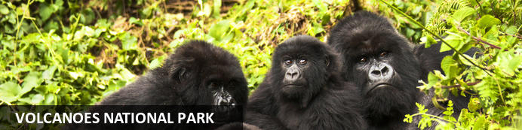

# 4 Days Rwanda Primate Tracking Safari

*Volcanoes National Park*  
*4 Days / 3 Nights*  
*0 Persons*  
*Date of Issue: 15 October 2023*

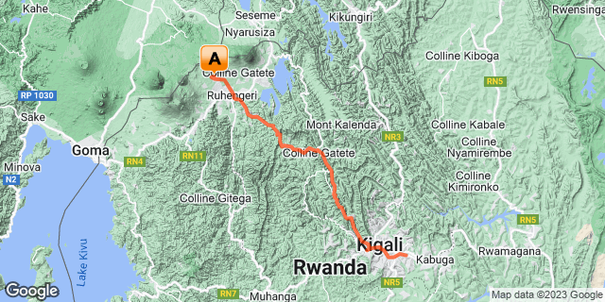

## Introduction

|  |  |  |  |  |  |
| --- | --- | --- | --- | --- | --- |
| **Start** | **Accommodation** | **Type** | **Destination** | **Basis** | **Duration** |
| Day 1 | One & Only Gorilla's Nest |  | Volcanoes National Park |  | **3 Nights** |
|  | → Virunga Inn Resort & Spa | alternate |  |  |  |

**Key**  
B&B: Bed and Breakfast

## Included

•  Airport transfers.   
• Airport and inter-hotel transfers from day 1 to the last day.  
•    All activities as highlighted in the itinerary.   
•    3 Nights at Volcanoes National Park.  
•    1 Gorilla permit per person (this includes briefing at RDB offices, guide, and trek – US$ 1500.-)  
•    1 Golden monkey permit per person (this includes briefing at RDB offices, guide, and trek – US$ 100.-)  
• Exclusive use of a private safari land cruiser  4x4   
•Services of a professional, experienced English-speaking driver guide.  
•Village/ Cultural Visit to Volcanoes.  
•Kigali Genocide Visit.   
•Bottled mineral water in the vehicle during the tour.  
•Our assistance.

## Excluded

* International and domestic airline tickets unless indicated,
* All extra activities, visits, entrances, and extra meals/drinks are not mentioned in the itinerary.
* Entry visa fees,
* Optional extras whilst in Kigali.
* Drinks throughout the trip,
* Tips and gratuities,
* Personal expenses such as telephone calls, mini bar, porter-age, travel insurance, etc.

## Day 1: One & Only Gorilla's Nest, Volcanoes National Park

### Volcanoes National Park

Bordering the Democratic Republic of Congo in Rwanda, and set high on the jungle-covered slopes of the volcanic Virunga Mountains, the Volcanoes National Park is best known as a sanctuary for the region’s rare mountain gorillas. Visitors flock here to experience face to face encounters with these intriguing creatures. Regulated treks through the reserve allow visitors to spend an hour at a time with these incredible primates in their natural habitat. While the gorillas are without a doubt the main drawcard, visitors can also look forward to exploring a network of scenic hiking trails, with the beautiful day hike to the crater lake on Mount Bisoke being a particular highlight. Make sure to visit the fascinating Karisoke Research Centre and the tomb of the world-famous Dian Fossey.

### Day Itinerary

* 0900: Pick up from Kigali International Airport
* 0915: Transfer  to Volcanoes National Park
* 1230: Arrival at your lodge for your check-in.
* 1300: Lunch for the day.
* 1530: **Afternoon relaxation at the Lodge.**
* 1800: Dinner and overnight stay at your lodge.

### Overnight: One & Only Gorilla's Nest

Cushioned in the foothills of the breathtaking Virunga Volcano range, One&Only Gorilla’s Nest makes the magical possible as you enjoy a once-in-a-lifetime, personal encounter with the rare and majestic mountain gorilla, roaming free in its own natural habitat. Offering an exclusive front-row seat to the world’s most popular mountain gorilla sanctuary. You’ll be captivated as exotic colourful birds and one of the planet’s greatest array of primate species flourish before your eyes and welcome you into their world. Then retreat to your own world, a spectacular modern haven, where every creature comfort is yours to behold. An all-inclusive resort, guests can look forward to savoring locally inspired dishes and taking part in two complimentary daily on-resort experiences.

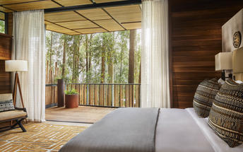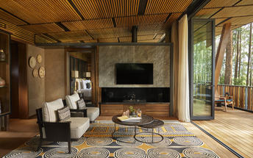

### Alternate: Virunga Inn Resort & Spa

Located in Kinigi, Rwanda, Virunga Inn Resort & Spa offers stylish accommodations with beautiful views of the mountains. The property features beautifully appointed rooms equipped with comfortable bedding, a private bathroom, a flat-screen TV, a safety deposit box, and a seating area. The property also features a 24-hour front desk, free Wi-Fi throughout, room service, and a restaurant serving a tasty breakfast each morning.

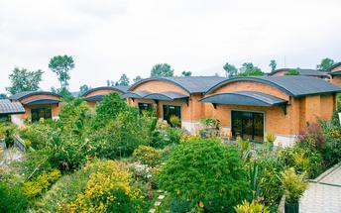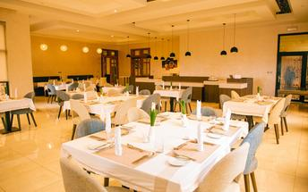

### Basis

Full Board - Dinner, Bed, Breakfast and Lunch

## Day 2: One & Only Gorilla's Nest, Volcanoes National Park

### Day Itinerary

* 0600: Breakfast and report to the park headquarters.
* 0800: Start the **gorilla trekking in Volcanoes National Park.**
* 1200: Estimated time of returning from the jungle.
* 1230: Lunch at a nearby facility before heading back to your lodge.
* 1500: Visit **Iby’ Iwacu cultural village.**
* 1800: Dinner and overnight stay at your lodge.

### Activities

|  |
| --- |
| Gorilla Trekking Volcanoes National Park |
| Iby'Iwacu Cultural Village |

#### Gorilla Trekking Volcanoes National Park

Gorilla Trekking in the Volcanoes National Park offers visitors the unique opportunity of discovering the 10 families of gorillas that live within the national park. Visitors can enjoy a cup of coffee before the trek starts and will be separated into groups of 8 depending on their physical abilities. Each group is guided by a guide and two scouts who are well trained in emergency situations. The amount of time set aside per trek is different depending on where the gorilla family is situated. Some trips may take as little as half an hour and some taking the better part of the day.

#### Iby'Iwacu Cultural Village

Offering an adventurous stay in a traditional rural, Rwandan village that has existed for centuries living with and next to mountain gorillas in Parc National des Volcans. Iby’Iwacu Cultural Village gives you a rare chance to meet local people, in their environment, with a taste of our culture and traditions. The community you visit will genuinely welcome you as a special guest while they proudly present to you aspects of their traditions and beliefs. This will truly be an experience of a lifetime as you home stay with the community and become part of their family

### Basis

Full Board - Dinner, Bed, Breakfast and Lunch

## Day 3: One & Only Gorilla's Nest, Volcanoes National Park

### Day Itinerary

* 0600: Breakfast and report to the park headquarters.
* 0800: Start the **golden monkey trekking in Volcanoes National Park.**
* 1200: Estimated time of returning from the jungle.
* 1230: Lunch at  the lodge
* 1400: Afternoon relaxation
* 1830: Dinner and Overnight stay at the Lodge.

### Activities

|  |
| --- |
| Volcanoes National Park Golden Monkey Trekking |

#### Volcanoes National Park Golden Monkey Trekking

Volcanoes National Park in Rwanda offers Golden monkeys trekking. This unique experience allows guests in groups of up to eight to look for and discover golden monkeys within their natural habitat.

The monkeys are incredibly active and enjoy showing off for tourists and researchers that they encounter daily. The monkeys can be found closer to the base of the volcano and enjoy eating the bamboo vegetation in the area.

### Basis

Bed and Breakfast

## Day 4: End of Itinerary

### Day Itinerary

* 0800: Begin the day with breakfast.
* 0900: Transfer and return to Kigali.
* 1130: Estimated time of arrival in Kigali.
* 1145: Visit Kigali Genocide Memorial Centre.
* 1300: Lunch for the day
* 1630: Transfer to Kigali International Airport for your outbound flight.
* TBA: Flight time departing Kigali. End of service.

### Activities

|  |
| --- |
| Kigali Genocide Memorial & Museum |

#### Kigali Genocide Memorial & Museum

Located just outside of Kigali City Centre in the Gasabo district, Kigali Genocide Memorial & Museum was created by a joint partnership of the Kigali City Council and the UK-based Aegis Trust. The centre is an extremely moving, challenging, educational and ultimately inspiring as well as a great place to understand the cause, tragedy and successful rebuilding post-genocide.

The memorial hosts a tour which is transparent and educational but very sombre and humbling when guests realise that over 250,000 deceased are buried on the site of the memorial.

### Basis

Breakfast and Lunch

# Transport

## Transfers

|  |  |  |  |  |  |
| --- | --- | --- | --- | --- | --- |
| **Date** | **Company** | **Pick Up** | **Drop Off** | **Time** | **Vehicle** |
|  |  | Kigali International Airport [KGL] | One & Only Gorilla's Nest |  | Transfer |
|  |  | One & Only Gorilla's Nest | Kigali International Airport [KGL] |  | Transfer |