

# 5 Days Nyungwe Forest National Park Tour

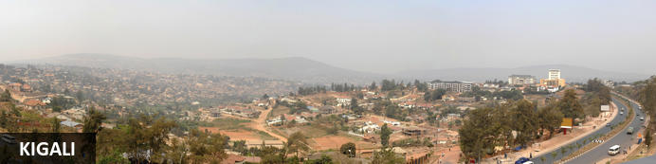

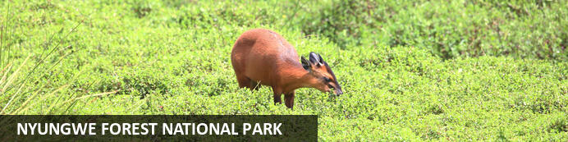

# 5 Days Nyungwe Forest National Park Tour

*Kigali - Nyungwe Forest National Park*  
*5 Days / 4 Nights*  
*0 Persons*  
*Date of Issue: 15 October 2023*

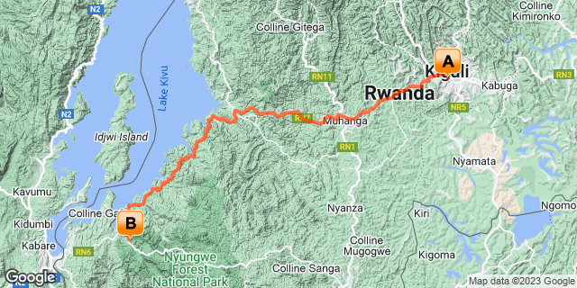

## Introduction

|  |  |  |  |  |
| --- | --- | --- | --- | --- |
| **Start** | **Accommodation** | **Destination** | **Basis** | **Duration** |
| Day 1 | Kigali Marriott Hotel | Kigali | HB | **1 Night** |
| Day 2 | One & Only Nyungwe House | Nyungwe Forest National Park | FB+ | **3 Nights** |

**Key**  
HB: Half Board - Dinner, Bed and Breakfast  
B&B: Bed and Breakfast  
FB+: Full Board Plus - Dinner, Bed, Breakfast, Lunch and Activities

## Included

•    All airport transfers  
•    1 Night at Kigali Marriott Hotel   
•  3 Nights at One & Only Nyungwe House.  
•    All activities as highlighted in the itinerary  
•    1 Chimp trek permit per person (this includes briefing at RDB offices, guide, and trek per person.  
•    Canopy walk permit per person (this includes briefing at RDB offices, guide, and trek per person.  
•    Colobus Monkey trek.   
• Exclusive use of a private safari land cruiser  4x4   
•Services of a professional, experienced English-speaking guide.  
•Bottled mineral water in the vehicle during the tour.  
•Our assistance.

## Excluded

* International and domestic airline tickets unless indicated,
* All extra activities, visits, entrances and extra meals/drinks not  mentioned in the itinerary
* Entry visa fees,
* Drinks throughout the trip,
* Tips and gratuities,
* Personal expenses such as telephone calls, mini bar, porter-age, travel insurance, etc.

## Day 1: Kigali Marriott Hotel, Kigali

### Kigali

Rwanda’s capital and biggest city stretches across lush undulating hills surrounded by towering mountains, the largest of which is Mount Kigali, rising 1850 metres above sea level. Kigali is the country’s financial, commercial and cultural hub, served by an international airport and featuring a wide range of accommodation options. It also offers a collection of restaurants and points of interest, including the Kigali Genocide Centre, an atmospheric market and numerous craft shops. With its interesting architecture, busy streets, meandering boulevards, and green hillsides, Kigali is said to be one of the most attractive cities in Africa and is definitely worth a visit.

### Day Itinerary

* TBA: Arrival time flight time into Kigali Rwanda.
* TBA: Pick up from Kigali International Airport for a 25-minute transfer to Kigali hotel.
* TBA: Arrival at your hotel for Check-in.
* TBA: Overnight stay at the Kigali Marriott Hotel.

### Overnight: Kigali Marriott Hotel

Experience the highest standard of comfort and convenience at Kigali Marriott Hotel. This premier luxury business hotel in Kigali is conveniently located along KN3 Avenue in downtown Kigali, close to the financial district, embassies, government ministries and Kigali City Hall. Timeless elegance surrounds you on arrival to a modern and spacious lobby and grand stairs. Experience spacious guest rooms decorated in warm pastel colors and fitted with the latest in technology. Visit Cucina Restaurant for tasty, innovative Italian fare and Lobby Bar for cocktails and city vistas. Complete your stay with a day of pampering at Saray Spa, the largest spa in the city, with its 5-star treatments and outdoor pool. Featuring the largest meeting space in the city, the hotel in Kigali is ideal for hosting productive conventions, elegant weddings and retreats of all sizes. Whether here for business or leisure, their Kigali luxury hotel offers all the amenities you'll need for an unforgettable retreat in Kigali, Rwanda.



### Basis

Half Board - Dinner, Bed and Breakfast

## Day 2: One & Only Nyungwe House, Nyungwe Forest National Park

### Nyungwe Forest National Park

Situated in southwestern Rwanda, the Nyungwe Forest National Park is known for its exceptional biodiversity and its wide range of endemic species. The park is composed of lush tracts of rainforest set high up on fertile mountain slopes. It is one of Africa’s most ancient forests and the home of Rwanda’s sole remaining chimpanzee population, as well as 85 additional mammal species, 43 reptile species, nearly 300 bird species and over 1000 plant species. Visitors can enjoy spotting colobus monkeys and chimpanzees hiding in the trees, hiking on a well-maintained network of trails passing through lush equatorial rainforest and catching a glimpse of a beautiful array of colourful birdlife. Don’t miss the thrilling Canopy Walk; it is one of its kind in Africa and offers impressive views of the forest.

### Day Itinerary

* 0700: Pick up and transfer to Nyungwe
* 1140: Estimated arrival time in Nyungwe.
* 1200: Check in at your lodge.
* 1230: Lunch at the lodge.
* 1500: **Afternoon take part in a complimentary lodge activity.**
* 1800: Dinner and overnight stay at your lodge.

### Overnight: One & Only Nyungwe House

Nestled on the edge of the vast and ancient Nyungwe rainforest, within the lush green expanse of a working tea plantation, One&Only Nyungwe House in Rwanda offers guests the opportunity to go where few have gone before, with once-in-a-lifetime experiences in one of the world’s most exceptional natural locations. Immersed in wild beauty surrounded by awe-inspiring jungle views, every element of the resort has been carefully considered, with inspired farm-to-table dining, spa and wellness offerings that embrace nature and local traditions, and curated, authentic experiences to discover.

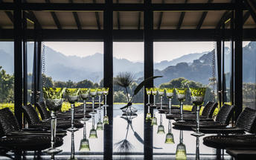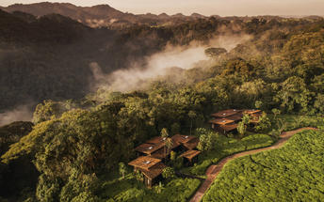

### Basis

Full Board Plus - Dinner, Bed, Breakfast, Lunch and Activities

## Day 3: One & Only Nyungwe House, Nyungwe Forest National Park

### Day Itinerary

* 0500: Begin the day with a morning breakfast.
* 0530: Prepare for transfers to Park headquarters for Chimpanzee trek briefing.
* 0530: Start the **Chimpanzee trekking in Nyungwe forests.**
* 1230: Estimated time to return from the jungle.
* 1330: Lunch at the Lodge
* 1500: Afternoon **Canopy Walk in Nyungwe.**
* 1800: Dinner and overnight stay at the lodge.

### Activities

|  |
| --- |
| Nyungwe Chimp Trekking |
| Nyungwe Forest National Park Canopy Walkway |

#### Nyungwe Chimp Trekking

This is the best place in Rwanda to see chimpanzees.

#### Nyungwe Forest National Park Canopy Walkway

The Canopy Walkway is located in Nyungwe National Park, Rwanda. Hanging 60 metres above the forest floor between giant trees and towers, visitors can experience the rainforest from a new perspective.

The walkway provides a stunning view of the park’s amazing wildlife and nature and is accessible as part of a specialized guided tour along the Igishigishigi trail. Visitors can also take self-guided tours, hiking along the Imbaraga or Umuyove trails.

### Basis

Full Board Plus - Dinner, Bed, Breakfast, Lunch and Activities

## Day 4: One & Only Nyungwe House, Nyungwe Forest National Park

### Day Itinerary

* 0700: Begin the day with a morning breakfast.
* 0800: Prepare for transfers to Park headquarters for Colobus Monkey trek briefing.
* 0900: Start Your Colobus Monkey Trek
* 1230: Estimated time to return from the jungle.
* 1330: Lunch at the Lodge
* 1500: Afternoon **relaxation.**
* 1800: Dinner and overnight stay at the lodge

### Activities

|  |
| --- |
| One & Only Nyungwe House Colobus Monkey Trekking |

#### One & Only Nyungwe House Colobus Monkey Trekking

Colobus Monkey Trekking is an activity provided by One&Only Nyungwe House. Guests can embrace the home of East Africa’s most diverse primate population while tracking the Colobus monkeys through Nyungwe’s lush forest trails. Most active and visible in the early morning, an early rise is required for maximum viewing opportunity, and a beautifully prepared breakfast will be enjoyed ‘on the go’. Guests are taken to the only location in Africa where Colobus monkeys can be encountered, and one of the few places on the planet where L’Hoests’s monkeys can be seen. With a maximum of 8 people per tour, this popular and challenging adventure requires early advanced booking. As this experience is authentically wild, primate viewing cannot be guaranteed. Please note, children must be fifteen years or over to take part in this activity.

### Basis

Full Board Plus - Dinner, Bed, Breakfast, Lunch and Activities

## Day 5: End of Itinerary

### Day Itinerary

* 0800: Begin the day with a morning breakfast.
* 0900: Drive back to Kigali.
* 1300: Lunch enroute.
* 1600: Estimated time of arrival and proceed with your international flight connection.
* 1800: End of service.

### Basis

Breakfast and Lunch

# Transport

## Transfers

|  |  |  |  |  |  |
| --- | --- | --- | --- | --- | --- |
| **Date** | **Company** | **Pick Up** | **Drop Off** | **Time** | **Vehicle** |
|  |  | Kigali Marriott Hotel | Kigali Marriott Hotel |  | Transfer |
|  |  | Kigali Marriott Hotel | One & Only Nyungwe House |  | Transfer |
|  |  | One & Only Nyungwe House | Kigali International Airport [KGL] |  | Transfer |