

# 5 Days Rwanda Wildlife Safari Adventure

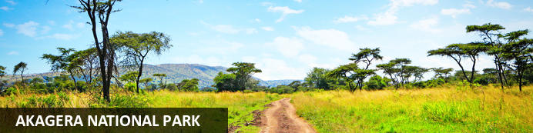

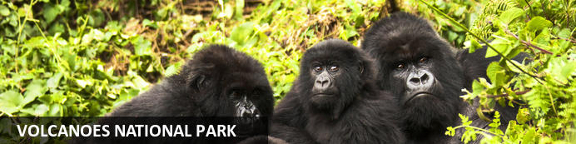

# 5 Days Rwanda Wildlife Safari Adventure

*Akagera National Park - Volcanoes National Park*  
*5 Days / 4 Nights*  
*0 Persons*  
*Date of Issue: 15 October 2023*

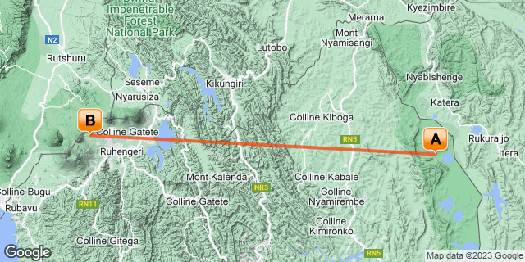

## Introduction

|  |  |  |  |  |
| --- | --- | --- | --- | --- |
| **Start** | **Accommodation** | **Destination** | **Basis** | **Duration** |
| Day 1 | Wilderness Magashi | Akagera National Park | FB | **2 Nights** |
| Day 3 | Wilderness Bisate | Volcanoes National Park | FB | **2 Nights** |

**Key**  
B&B: Bed and Breakfast  
FB: Full Board - Dinner, Bed, Breakfast and Lunch

## Included

• Airport and inter-hotel transfers from day 1 to the last day.  
•    All activities as highlighted in the itinerary.   
•    2 Nights at Akagera National Park.  
•    2 Nights at Volcanoes National Park.  
•    1 Gorilla permit per person (this includes briefing at RDB offices, guide, and trek – US$ 1500.-)  
•    Game Drive in Akagera.   
•    Boat Safari in Akagera.   
• Exclusive use of a private safari land cruiser  4x4   
•Services of a professional, experienced English-speaking driver guide.  
•Village/ Cultural Visit to Volcanoes.  
•Bottled mineral water in the vehicle during the tour.  
•Our assistance.

## Excluded

* International and domestic airline tickets unless indicated,
* All extra activities, visits, entrances, and extra meals/drinks are not mentioned in the itinerary.
* Entry visa fees,
* Optional extras whilst in Kigali.
* Drinks throughout the trip,
* Tips and gratuities,
* Personal expenses such as telephone calls, mini bar, porter-age, travel insurance, etc.

## Day 1: Wilderness Magashi, Akagera National Park

### Akagera National Park

Bordering Tanzania in eastern Rwanda, Akagera National Park is central Africa's largest protected wetland and the last refuge for savannah-adapted species in the country. Stretching across a vast expanse of low-lying mountains and savannah plains, the park takes in the rolling highlands woodlands, swamp-fringed lakes, and wetlands of the Kagera River along the way. Crocodiles and hippos wallow in the park's watery basins, predators prowl through its acacia groves, and elephant, zebra, giraffe, buffalo and other animals roam across its grassy plains. Bursting with a rich biodiversity, the park features a variety of rare species, as well as a plentitude of mammals and hundreds of bird species.

### Day Itinerary

* 0700: Pick up from Kigali City.
* 0730: Transfer to Akagera National Park.
* 1000: Pick up from the North Gate and transfer to Magashi Camp.
* 1230: Lunch at the lodge.
* 1400: **Embark on the Lodge's activities by Magashi-** Game drive in Kilala Plains.
* 1830: Dinner and overnight stay at your lodge.

### Overnight: Wilderness Magashi

Wilderness Magashi is situated in the productive and phenomenally diverse north-eastern corner of Akagera National Park, overlooking scenic Lake Rwanyakazinga. Akagera comprises some of the most scenic savannah in East Africa – open plains, woodlands, lakes, swamp and grassy low mountains – and is home to one of Africa’s highest hippo densities, large crocodiles, as well as the rare sitatunga and boasting an impressive 520 species of birds. Teeming with plains game, Akagera now also boasts a healthy population of lion which were introduced by African Parks in 2015 after a 20-year absence; black rhino were reintroduced in 2017, and white rhino in 2021. Wilderness Magashi – the only exclusive-use area in Akagera – also harbours a good density of leopard.

INSIDER'S TIP: Our core Purpose in Akagera is to help conserve Rwanda’s last protected savannah ecosystem, and species like black rhino and the rare and elusive shoebill; furthermore, our presence here will contribute towards enabling it to become economically self-sufficient for the first time.

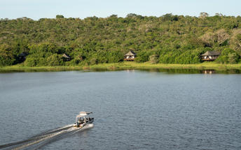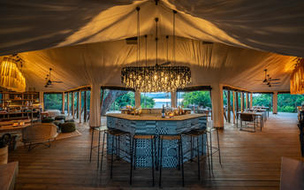

### Basis

Full Board - Dinner, Bed, Breakfast and Lunch

## Day 2: Wilderness Magashi, Akagera National Park

### Day Itinerary

* 0630: Begin the day with a morning breakfast.
* 0700: Morning **game drive** in Akagera National Park and other day activities by the lodge.
* 1400: **Boat safari in Akagera** on Lake Rwanyakizinga.
* 1800: Dinner and overnight stay at Magashi Camp.

### Activities

|  |
| --- |
| Magashi Game Drives |
| Magashi Boating |

#### Magashi Game Drives

Explore the area in an open 4x4 vehicle with each vehicle able to accommodate a maximum of seven guests, allowing each individual an outside seat.

#### Magashi Boating

Magashi offers boating in eight-seater swamp cruisers. This is an excellent way to view the water birds and many other aquatic animals seen around Lake Rwanyakazinga.

### Basis

Full Board - Dinner, Bed, Breakfast and Lunch

## Day 3: Wilderness Bisate, Volcanoes National Park

### Volcanoes National Park

Bordering the Democratic Republic of Congo in Rwanda, and set high on the jungle-covered slopes of the volcanic Virunga Mountains, the Volcanoes National Park is best known as a sanctuary for the region’s rare mountain gorillas. Visitors flock here to experience face to face encounters with these intriguing creatures. Regulated treks through the reserve allow visitors to spend an hour at a time with these incredible primates in their natural habitat. While the gorillas are without a doubt the main drawcard, visitors can also look forward to exploring a network of scenic hiking trails, with the beautiful day hike to the crater lake on Mount Bisoke being a particular highlight. Make sure to visit the fascinating Karisoke Research Centre and the tomb of the world-famous Dian Fossey.

### Day Itinerary

* 0800: Morning breakfast.
* 0900: Transfer to Kigali.
* 1130: Arrive in Kigali and continue to Volcanoes National Park.
* 1330: Arrival at your lodge for your check-in.
* 1400: Lunch for the day.
* 1530: **Afternoon relaxation at the Lodge.**
* 1800: Dinner and overnight stay at your lodge.

### Overnight: Wilderness Bisate

Wilderness Bisate is located in the natural amphitheatre of an eroded volcanic cone and has dramatic views of the peaks of the volcanoes, Bisoke and Karisimbi, rearing up through the Afro-alpine forests of nearby Volcanoes National Park. Six luxurious en-suite Forest Villas maximise comfort and views, while retaining environmental principles and reflecting the culture of rural Rwanda. Each guest contributes to Bisate’s biodiversity conservation and local community projects – making a far-reaching impact on an iconic endangered species: the mountain gorilla.

Aside from tracking one of the several habituated gorilla groups, activities include visiting nearby natural attractions, hiking to Dian Fossey’s burial site, and observing the Park’s group of endangered endemic golden monkey. Walks on Bisate’s property offer birding and participation in the reforestation programme.

INSIDER’S TIP: Wilderness Bisate is within easy driving distance of Volcanoes National Park Headquarters, from where gorilla treks depart daily.

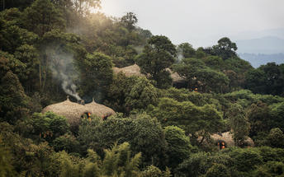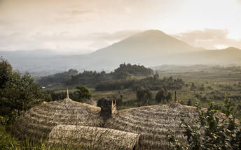

### Basis

Full Board - Dinner, Bed, Breakfast and Lunch

## Day 4: Wilderness Bisate, Volcanoes National Park

### Day Itinerary

* 0600: Breakfast and report to the park headquarters.
* 0800: Start the **gorilla trekking in Volcanoes National Park.**
* 1200: Estimated time of returning from the jungle.
* 1230: Lunch at a nearby facility before heading back to your lodge.
* 1500: Visit **Iby’ Iwacu cultural village.**
* 1800: Dinner and overnight stay at your lodge.

### Activities

|  |
| --- |
| Gorilla Trekking Volcanoes National Park |
| Iby'Iwacu Cultural Village |

#### Gorilla Trekking Volcanoes National Park

Gorilla Trekking in the Volcanoes National Park offers visitors the unique opportunity of discovering the 10 families of gorillas that live within the national park. Visitors can enjoy a cup of coffee before the trek starts and will be separated into groups of 8 depending on their physical abilities. Each group is guided by a guide and two scouts who are well trained in emergency situations. The amount of time set aside per trek is different depending on where the gorilla family is situated. Some trips may take as little as half an hour and some taking the better part of the day.

#### Iby'Iwacu Cultural Village

Offering an adventurous stay in a traditional rural, Rwandan village that has existed for centuries living with and next to mountain gorillas in Parc National des Volcans. Iby’Iwacu Cultural Village gives you a rare chance to meet local people, in their environment, with a taste of our culture and traditions. The community you visit will genuinely welcome you as a special guest while they proudly present to you aspects of their traditions and beliefs. This will truly be an experience of a lifetime as you home stay with the community and become part of their family

### Basis

Full Board - Dinner, Bed, Breakfast and Lunch

## Day 5: End of Itinerary

### Day Itinerary

* 0800: Begin the day with breakfast.
* 0900: Transfer and return to Kigali.
* 1130: Estimated time of arrival in Kigali.
* 1145: Visit Kigali Genocide Memorial Centre.
* 1300: Lunch for the day
* 1630: Transfer to Kigali International Airport for your outbound flight.
* TBA: Flight time departing Kigali. End of service.

### Activities

|  |
| --- |
| Kigali Genocide Memorial & Museum |

#### Kigali Genocide Memorial & Museum

Located just outside of Kigali City Centre in the Gasabo district, Kigali Genocide Memorial & Museum was created by a joint partnership of the Kigali City Council and the UK-based Aegis Trust. The centre is an extremely moving, challenging, educational and ultimately inspiring as well as a great place to understand the cause, tragedy and successful rebuilding post-genocide.

The memorial hosts a tour which is transparent and educational but very sombre and humbling when guests realise that over 250,000 deceased are buried on the site of the memorial.

### Basis

Breakfast and Lunch

# Transport

## Flight Information

|  |  |  |  |  |  |  |  |  |
| --- | --- | --- | --- | --- | --- | --- | --- | --- |
| **Date** | **Flight** | **Airline** | **Departure Airport** | **Time** | **Arrival Airport** | **Time** | **Class** | **Ref** |
|  | Scheduled |  | Kigali City |  | Wilderness Magashi |  |  |  |

## Transfers

|  |  |  |  |  |  |
| --- | --- | --- | --- | --- | --- |
| **Date** | **Company** | **Pick Up** | **Drop Off** | **Time** | **Vehicle** |
|  |  | Wilderness Magashi | Wilderness Bisate |  | Transfer |
|  |  | Wilderness Bisate | Kigali International Airport [KGL] |  | Transfer |