

# 5 Days Tracking Gorillas and Chimpanzees in Rwanda

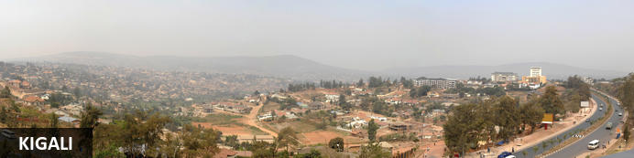

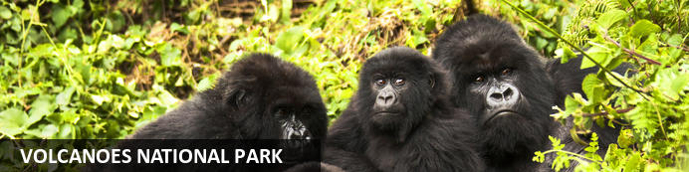

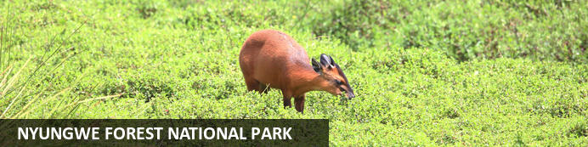

# 5 Days Tracking Gorillas and Chimpanzees in Rwanda

*Kigali - Volcanoes National Park - Nyungwe Forest National Park*  
*5 Days / 4 Nights*  
*0 Persons*  
*Date of Issue: 22 October 2023*

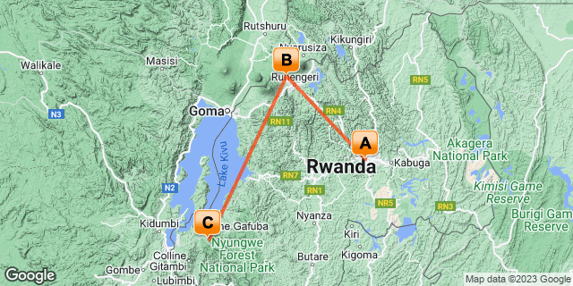

## Introduction

|  |  |  |  |  |
| --- | --- | --- | --- | --- |
| **Start** | **Accommodation** | **Destination** | **Basis** | **Duration** |
| Day 1 | Kigali Marriott Hotel | Kigali | HB | **1 Night** |
| Day 2 | One & Only Gorilla's Nest | Volcanoes National Park | FB+ | **1 Night** |
| Day 3 | One & Only Nyungwe House | Nyungwe Forest National Park | FB+ | **2 Nights** |

**Key**  
HB: Half Board - Dinner, Bed and Breakfast  
B&B: Bed and Breakfast  
FB+: Full Board Plus - Dinner, Bed, Breakfast, Lunch and Activities

## Included

•    All airport transfers  
•    1 Night at Kigali Marriott Hotel   
•  3 Nights at One & Only Nyungwe House.  
•    All activities as highlighted in the itinerary  
•    1 Chimp trek permit per person (this includes briefing at RDB offices, guide, and trek per person.  
•    Canopy walk permit per person (this includes briefing at RDB offices, guide, and trek per person.  
•    Colobus Monkey trek.   
• Exclusive use of a private safari land cruiser  4x4   
•Services of a professional, experienced English-speaking guide.  
•Bottled mineral water in the vehicle during the tour.  
•Our assistance.

## Excluded

* International and domestic airline tickets unless indicated,
* All extra activities, visits, entrances and extra meals/drinks not  mentioned in the itinerary
* Entry visa fees,
* Drinks throughout the trip,
* Tips and gratuities,
* Personal expenses such as telephone calls, mini bar, porter-age, travel insurance, etc.

## Day 1: Kigali Marriott Hotel, Kigali

### Kigali

Rwanda’s capital and biggest city stretches across lush undulating hills surrounded by towering mountains, the largest of which is Mount Kigali, rising 1850 metres above sea level. Kigali is the country’s financial, commercial and cultural hub, served by an international airport and featuring a wide range of accommodation options. It also offers a collection of restaurants and points of interest, including the Kigali Genocide Centre, an atmospheric market and numerous craft shops. With its interesting architecture, busy streets, meandering boulevards, and green hillsides, Kigali is said to be one of the most attractive cities in Africa and is definitely worth a visit.

### Day Itinerary

* TBA: Arrival time flight time into Kigali Rwanda.
* TBA: Pick up from Kigali International Airport for a 25-minute transfer to Kigali hotel.
* TBA: Arrival at your hotel for Check-in.
* TBA: Overnight stay at the Kigali Marriott Hotel.

### Overnight: Kigali Marriott Hotel

Experience the highest standard of comfort and convenience at Kigali Marriott Hotel. This premier luxury business hotel in Kigali is conveniently located along KN3 Avenue in downtown Kigali, close to the financial district, embassies, government ministries and Kigali City Hall. Timeless elegance surrounds you on arrival to a modern and spacious lobby and grand stairs. Experience spacious guest rooms decorated in warm pastel colors and fitted with the latest in technology. Visit Cucina Restaurant for tasty, innovative Italian fare and Lobby Bar for cocktails and city vistas. Complete your stay with a day of pampering at Saray Spa, the largest spa in the city, with its 5-star treatments and outdoor pool. Featuring the largest meeting space in the city, the hotel in Kigali is ideal for hosting productive conventions, elegant weddings and retreats of all sizes. Whether here for business or leisure, their Kigali luxury hotel offers all the amenities you'll need for an unforgettable retreat in Kigali, Rwanda.

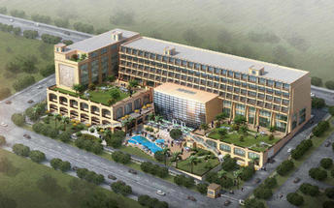

### Basis

Half Board - Dinner, Bed and Breakfast

## Day 2: One & Only Gorilla's Nest, Volcanoes National Park

### Volcanoes National Park

Bordering the Democratic Republic of Congo in Rwanda, and set high on the jungle-covered slopes of the volcanic Virunga Mountains, the Volcanoes National Park is best known as a sanctuary for the region’s rare mountain gorillas. Visitors flock here to experience face to face encounters with these intriguing creatures. Regulated treks through the reserve allow visitors to spend an hour at a time with these incredible primates in their natural habitat. While the gorillas are without a doubt the main drawcard, visitors can also look forward to exploring a network of scenic hiking trails, with the beautiful day hike to the crater lake on Mount Bisoke being a particular highlight. Make sure to visit the fascinating Karisoke Research Centre and the tomb of the world-famous Dian Fossey.

### Day Itinerary

* 0900:  Visit **Kigali Genocide Memorial Centre.**
* 1030: Ready for your drive to Volcanoes National Park.
* 1300: Arrival and check-in at your lodge.
* 1320: Lunch at the Lodge
* 1​500: Visit **Dian Fossey Gorilla Fund Museum,**
* 1800: Dinner and overnight stay.

### Overnight: One & Only Gorilla's Nest

Cushioned in the foothills of the breathtaking Virunga Volcano range, One&Only Gorilla’s Nest makes the magical possible as you enjoy a once-in-a-lifetime, personal encounter with the rare and majestic mountain gorilla, roaming free in its own natural habitat. Offering an exclusive front-row seat to the world’s most popular mountain gorilla sanctuary. You’ll be captivated as exotic colourful birds and one of the planet’s greatest array of primate species flourish before your eyes and welcome you into their world. Then retreat to your own world, a spectacular modern haven, where every creature comfort is yours to behold. An all-inclusive resort, guests can look forward to savoring locally inspired dishes and taking part in two complimentary daily on-resort experiences.

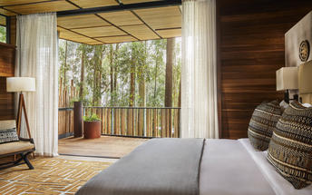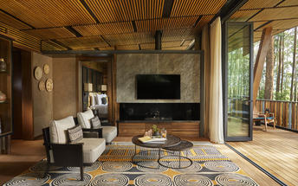

### Activities

|  |
| --- |
| Kigali Genocide Memorial & Museum |
| The Ellen DeGeneres Campus of the Dian Fossey Gorilla Fund |

#### Kigali Genocide Memorial & Museum

Located just outside of Kigali City Centre in the Gasabo district, Kigali Genocide Memorial & Museum was created by a joint partnership of the Kigali City Council and the UK-based Aegis Trust. The centre is an extremely moving, challenging, educational and ultimately inspiring as well as a great place to understand the cause, tragedy and successful rebuilding post-genocide.

The memorial hosts a tour which is transparent and educational but very sombre and humbling when guests realise that over 250,000 deceased are buried on the site of the memorial.

#### The Ellen DeGeneres Campus of the Dian Fossey Gorilla Fund

The Ellen DeGeneres Campus of the Dian Fossey Gorilla Fund is an expansive, 12-acre property that rests adjacent to the Volcanoes National Park in northern Rwanda. The campus showcases the best in sustainable architecture, local resourcing, and environmentally responsible practices and will offer state-of-the-art laboratories, a scientific conservation library, and meeting space for large groups. The goal of the campus is to inspire everyone who visits, to cherish gorillas and encourage a lifetime of conservation.

### Basis

Full Board Plus - Dinner, Bed, Breakfast, Lunch and Activities

## Day 3: One & Only Nyungwe House, Nyungwe Forest National Park

### Nyungwe Forest National Park

Situated in southwestern Rwanda, the Nyungwe Forest National Park is known for its exceptional biodiversity and its wide range of endemic species. The park is composed of lush tracts of rainforest set high up on fertile mountain slopes. It is one of Africa’s most ancient forests and the home of Rwanda’s sole remaining chimpanzee population, as well as 85 additional mammal species, 43 reptile species, nearly 300 bird species and over 1000 plant species. Visitors can enjoy spotting colobus monkeys and chimpanzees hiding in the trees, hiking on a well-maintained network of trails passing through lush equatorial rainforest and catching a glimpse of a beautiful array of colourful birdlife. Don’t miss the thrilling Canopy Walk; it is one of its kind in Africa and offers impressive views of the forest.

### Day Itinerary

* 0600: Begin the day with a morning breakfast.
* 0630: Transfer to the park headquarters for gorilla trekking briefing.
* 0800: Start the **gorilla trekking in Volcanoes National Park.**
* 1200: Estimated time of returning from the jungle.
* 1230: Transfer back to the Lodge.
* 1300: Lunch at the Lodge.
* 1400: Prepare for a transfer to Nyungwe
* 1800: Estimated time to arrive at Nyungwe
* 1900: Overnight stay at the hotel.

### Overnight: One & Only Nyungwe House

Nestled on the edge of the vast and ancient Nyungwe rainforest, within the lush green expanse of a working tea plantation, One&Only Nyungwe House in Rwanda offers guests the opportunity to go where few have gone before, with once-in-a-lifetime experiences in one of the world’s most exceptional natural locations. Immersed in wild beauty surrounded by awe-inspiring jungle views, every element of the resort has been carefully considered, with inspired farm-to-table dining, spa and wellness offerings that embrace nature and local traditions, and curated, authentic experiences to discover.

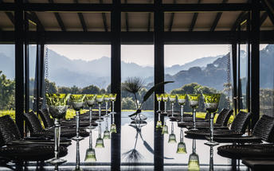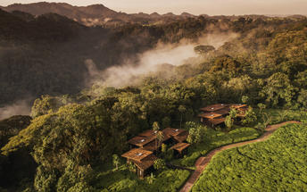

### Basis

Full Board Plus - Dinner, Bed, Breakfast, Lunch and Activities

## Day 4: One & Only Nyungwe House, Nyungwe Forest National Park

### Day Itinerary

* 0500: Begin the day with a morning breakfast.
* 0530: Prepare for transfers to Park headquarters for Chimpanzee trek briefing.
* 0530: Start the **Chimpanzee trekking in Nyungwe forests.**
* 1230: Estimated time to return from the jungle.
* 1330: Lunch at the Lodge
* 1500: Afternoon **Canopy Walk in Nyungwe.**
* 1800: Dinner and overnight stay at the lodge.

### Activities

|  |
| --- |
| Nyungwe Chimp Trekking |
| Nyungwe Forest National Park Canopy Walkway |

#### Nyungwe Chimp Trekking

This is the best place in Rwanda to see chimpanzees.

#### Nyungwe Forest National Park Canopy Walkway

The Canopy Walkway is located in Nyungwe National Park, Rwanda. Hanging 60 metres above the forest floor between giant trees and towers, visitors can experience the rainforest from a new perspective.

The walkway provides a stunning view of the park’s amazing wildlife and nature and is accessible as part of a specialized guided tour along the Igishigishigi trail. Visitors can also take self-guided tours, hiking along the Imbaraga or Umuyove trails.

### Basis

Full Board Plus - Dinner, Bed, Breakfast, Lunch and Activities

## Day 5: End of Itinerary

### Day Itinerary

* 0800: Begin the day with a morning breakfast.
* 0900: Drive back to Kigali.
* 1300: Lunch en route.
* 1600: Estimated time of arrival and proceed with your international flight connection.
* 1800: End of service.

### Basis

Breakfast and Lunch

# Transport

## Transfers

|  |  |  |  |  |  |
| --- | --- | --- | --- | --- | --- |
| **Date** | **Company** | **Pick Up** | **Drop Off** | **Time** | **Vehicle** |
|  |  | Kigali Marriott Hotel | Kigali Marriott Hotel |  | Transfer |
|  |  | Kigali Marriott Hotel | One & Only Gorilla's Nest |  | Transfer |
|  |  | One & Only Gorilla's Nest | One & Only Nyungwe House |  | Transfer |
|  |  | One & Only Nyungwe House | Kigali International Airport [KGL] |  | Transfer |