

# 6 Days Best of Rwanda Wildlife Safari Tour

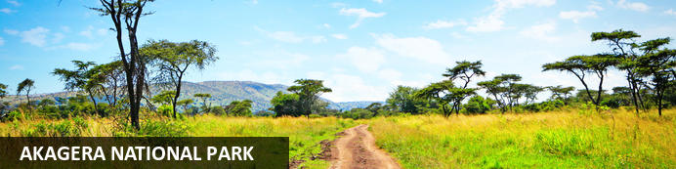

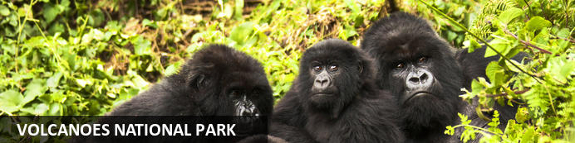

# 6 Days Best of Rwanda Wildlife Safari Tour

*Akagera National Park - Volcanoes National Park*  
*6 Days / 5 Nights*  
*0 Persons*  
*Date of Issue: 22 October 2023*

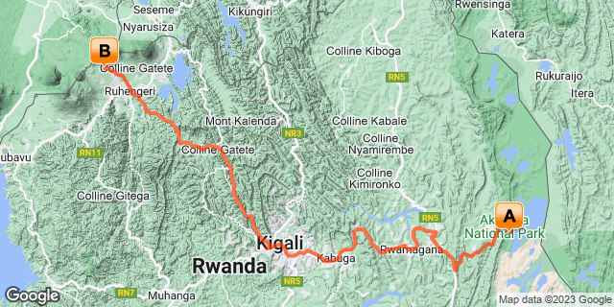

## Introduction

|  |  |  |  |  |
| --- | --- | --- | --- | --- |
| **Start** | **Accommodation** | **Destination** | **Basis** | **Duration** |
| Day 1 | Ruzizi Tented Lodge | Akagera National Park | FB | **2 Nights** |
| Day 3 | Virunga Inn Resort & Spa | Volcanoes National Park | FB | **3 Nights** |

**Key**  
B&B: Bed and Breakfast  
FB: Full Board - Dinner, Bed, Breakfast and Lunch

## Included

•    Airport and inter-hotel transfers from day 1 to the last day  
•    All activities as highlighted in the itinerary  
•    2 Nights at Accommodation at Akagera - All meals, All local drinks   
•  3 Nights at  Virunga Inn Resort & Spa -All meals, All local drinks   
•    One  Gorilla permit per person (this includes briefing at RDB offices, guide, and trek – US$ 1500.-)  
•All activities as per the itinerary.  
• Exclusive use of a private safari land cruiser 4x4 with WI-FI in receptive areas  
•Services of a professional, experienced English-speaking driver guide.  
•Dian Fossey Hike   
•Bottled mineral water in the vehicle during the tour.  
 • All government taxes.   
•Our assistance.

## Excluded

* International and domestic airline tickets unless indicated.
* All extra activities, visits, entrances, and extra meals/drinks not  mentioned in the itinerary
* Entry visa fees,
* Drinks throughout the trip,
* Tips and gratuities,
* Personal expenses such as telephone calls, mini bar, porter-age, travel insurance, etc.

## Day 1: Ruzizi Tented Lodge, Akagera National Park

### Akagera National Park

Bordering Tanzania in eastern Rwanda, Akagera National Park is central Africa's largest protected wetland and the last refuge for savannah-adapted species in the country. Stretching across a vast expanse of low-lying mountains and savannah plains, the park takes in the rolling highlands woodlands, swamp-fringed lakes, and wetlands of the Kagera River along the way. Crocodiles and hippos wallow in the park's watery basins, predators prowl through its acacia groves, and elephant, zebra, giraffe, buffalo and other animals roam across its grassy plains. Bursting with a rich biodiversity, the park features a variety of rare species, as well as a plentitude of mammals and hundreds of bird species.

### Day Itinerary

* 0900: Arrival at Kigali Interntaional Airport
* 1000: Visit **Kigali Genocide Memorial Centre.**
* 1130: Transfer to Akagera National Park
* 1400: Arrival at the Akagera National Park.
* 14150: Check in at your lodge with lunch for the day.
* 1500: Afternoon relaxation at the Lodge.
* 1800: Dinner and overnight stay at your lodge.

### Overnight: Ruzizi Tented Lodge

Ruzizi Tented Lodge is a luxury eco-lodge located on Lake Ihema. Its nine tents are set back from Ihema’s serene shores and hidden among swaying palms and fruiting fig trees. With a 20-guest maximum, the lodge is an intimate retreat. Each tent boasts an en-suite bathroom with hot and cold running water, a dressing area, and a cosy queen bed. Guests will also have access to a thatched reception and dining area and wooden walkways leading to a stunning deck that hangs over the lake. It contains a central fire pit and is the perfect spot for a morning cup of coffee or post-dinner digestif. The lodge is powered by solar energy and prides itself on being environmentally conscious.

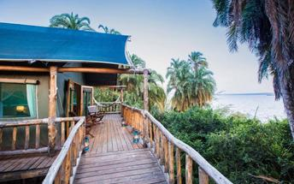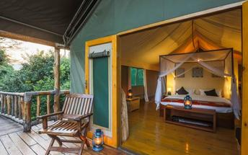

### Activities

|  |
| --- |
| Kigali Genocide Memorial & Museum |

#### Kigali Genocide Memorial & Museum

Located just outside of Kigali City Centre in the Gasabo district, Kigali Genocide Memorial & Museum was created by a joint partnership of the Kigali City Council and the UK-based Aegis Trust. The centre is an extremely moving, challenging, educational and ultimately inspiring as well as a great place to understand the cause, tragedy and successful rebuilding post-genocide.

The memorial hosts a tour which is transparent and educational but very sombre and humbling when guests realise that over 250,000 deceased are buried on the site of the memorial.

### Basis

Full Board - Dinner, Bed, Breakfast and Lunch

## Day 2: Ruzizi Tented Lodge, Akagera National Park

### Day Itinerary

* 0630: Begin the day with a morning breakfast.
* 0700: Morning **game drive** in Akagera National Park and other day activities by the lodge.
* 1600: Sunset **Boat safari in Akagera** on Lake Ihema
* 1800: Dinner and overnight stay at your Lodge

### Activities

|  |
| --- |
| Akagera National Park Game Drive |
| Boat Trip On Lake Ihema |

#### Akagera National Park Game Drive

Lead by a guide, Akagera National Park Game Drive occurs early in the mornings and late in the afternoons. While driving along the park tracks in a 4WD Safari vehicle, passengers will have the chance to spot animals such as hyenas, elephants, various buffalo and lions.

### Basis

Full Board - Dinner, Bed, Breakfast and Lunch

## Day 3: Virunga Inn Resort & Spa, Volcanoes National Park

### Volcanoes National Park

Bordering the Democratic Republic of Congo in Rwanda, and set high on the jungle-covered slopes of the volcanic Virunga Mountains, the Volcanoes National Park is best known as a sanctuary for the region’s rare mountain gorillas. Visitors flock here to experience face to face encounters with these intriguing creatures. Regulated treks through the reserve allow visitors to spend an hour at a time with these incredible primates in their natural habitat. While the gorillas are without a doubt the main drawcard, visitors can also look forward to exploring a network of scenic hiking trails, with the beautiful day hike to the crater lake on Mount Bisoke being a particular highlight. Make sure to visit the fascinating Karisoke Research Centre and the tomb of the world-famous Dian Fossey.

### Day Itinerary

* 0800: Begin the day with a morning breakfast.
* 0900: Ready to return to Kigali and transfer to Volcanoes.
* 1300: Lunch in Kigali.
* 1430: Continue to Volcanoes.
* 1800: **Estimated time of arrival and check in at your lodge.**
* 1800: Dinner and Overnight stay at your lodge.

### Overnight: Virunga Inn Resort & Spa

Located in Kinigi, Rwanda, Virunga Inn Resort & Spa offers stylish accommodations with beautiful views of the mountains. The property features beautifully appointed rooms equipped with comfortable bedding, a private bathroom, a flat-screen TV, a safety deposit box, and a seating area. The property also features a 24-hour front desk, free Wi-Fi throughout, room service, and a restaurant serving a tasty breakfast each morning.

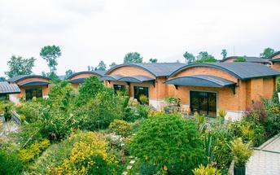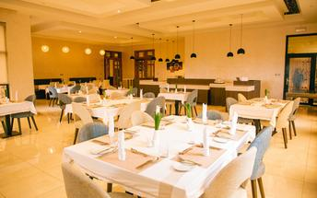

### Basis

Full Board - Dinner, Bed, Breakfast and Lunch

## Day 4: Virunga Inn Resort & Spa, Volcanoes National Park

### Day Itinerary

* 0600: Begin the day with a morning breakfast.
* 0630: Transfer to the park headquarters for gorilla trekking briefing.
* 0800: Start the **gorilla trekking in Volcanoes National Park.**
* 1200: Estimated time of returning from the jungle.
* 1230: Transfer back to the Lodge.
* 1300: Lunch at the Lodge.
* 1500: Visit **Iby ‘Iwacu cultural village.**
* 1800: Dinner and overnight stay at your lodge.

### Activities

|  |
| --- |
| Gorilla Trekking Volcanoes National Park |
| Iby'Iwacu Cultural Village |

#### Gorilla Trekking Volcanoes National Park

Gorilla Trekking in the Volcanoes National Park offers visitors the unique opportunity of discovering the 10 families of gorillas that live within the national park. Visitors can enjoy a cup of coffee before the trek starts and will be separated into groups of 8 depending on their physical abilities. Each group is guided by a guide and two scouts who are well trained in emergency situations. The amount of time set aside per trek is different depending on where the gorilla family is situated. Some trips may take as little as half an hour and some taking the better part of the day.

#### Iby'Iwacu Cultural Village

Offering an adventurous stay in a traditional rural, Rwandan village that has existed for centuries living with and next to mountain gorillas in Parc National des Volcans. Iby’Iwacu Cultural Village gives you a rare chance to meet local people, in their environment, with a taste of our culture and traditions. The community you visit will genuinely welcome you as a special guest while they proudly present to you aspects of their traditions and beliefs. This will truly be an experience of a lifetime as you home stay with the community and become part of their family

### Basis

Full Board - Dinner, Bed, Breakfast and Lunch

## Day 5: Virunga Inn Resort & Spa, Volcanoes National Park

### Day Itinerary

* 0600: Begin the day with a morning breakfast.
* 0630: Transfer to the park headquarters
* 0800: Start the hike to Dian Fossey tombs.
* 1200: Estimated time of returning from the jungle.
* 1230: Transfer back to the Lodge.
* 1300: Lunch at the Lodge.
* 1500: Afternoon relaxation.
* 1800: Dinner and overnight stay at your lodge.

### Activities

|  |
| --- |
| Volcanoes National Park Dian Fossey Tomb Tour |

#### Volcanoes National Park Dian Fossey Tomb Tour

Volcano National Park Dian Fossey Tomb Tour is located in Rwanda, Africa. The historic location was the home and research facility of primatologist Dian Fossey. Visitors can trek through the forest to reach the location, taking in the spectacular views. The trekking tour is about 1.5 hours long and visitors will see wildlife such as birds, forest hogs, forest elephants and a variety of primates.

### Basis

Full Board - Dinner, Bed, Breakfast and Lunch

## Day 6: End of Itinerary

### Day Itinerary

* 0800: Begin the day with a morning breakfast.
* 0900: Transfer and return to Kigali.
* 1200**:** Estimated arrival time in Kigali.
* 1230: Lunch in Kigali
* 1600: Transfer to Kigali International Airport for your outbound departure flight.
* 1800: End of service.

### Basis

Breakfast and Lunch

# Transport

## Transfers

|  |  |  |  |  |  |
| --- | --- | --- | --- | --- | --- |
| **Date** | **Company** | **Pick Up** | **Drop Off** | **Time** | **Vehicle** |
|  |  | Kigali International Airport [KGL] | Ruzizi Tented Lodge |  | Transfer |
|  |  | Ruzizi Tented Lodge | Virunga Inn Resort & Spa |  | Transfer |
|  |  | Virunga Inn Resort & Spa | Kigali International Airport [KGL] |  | Transfer |