

# 8 Days Rwanda Safari and Lake Kivu Tour

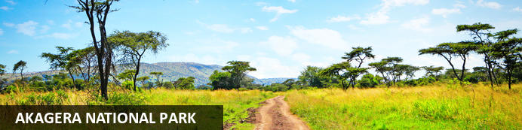

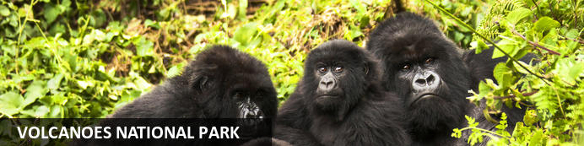

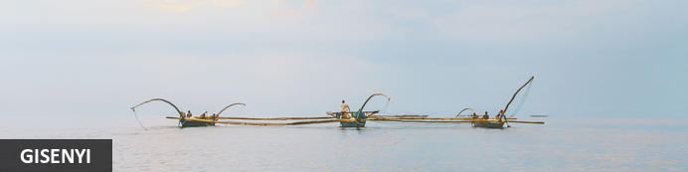

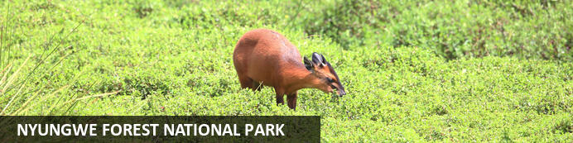

# 8 Days Rwanda Safari and Lake Kivu Tour

*Akagera National Park - Volcanoes National Park - Gisenyi - Nyungwe Forest National Park*  
*8 Days / 7 Nights*  
*0 Persons*  
*Date of Issue: 22 October 2023*

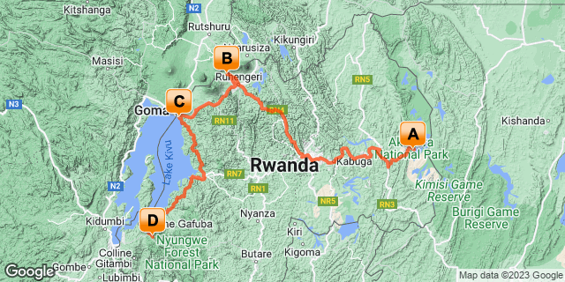

## Introduction

|  |  |  |  |  |
| --- | --- | --- | --- | --- |
| **Start** | **Accommodation** | **Destination** | **Basis** | **Duration** |
| Day 1 | Ruzizi Tented Lodge | Akagera National Park | FB | **2 Nights** |
| Day 3 | Virunga Inn Resort & Spa | Volcanoes National Park | FB | **2 Nights** |
| Day 5 | Lake Kivu Serena Hotel | Gisenyi | FB | **1 Night** |
| Day 6 | One & Only Nyungwe House | Nyungwe Forest National Park | B&B | **2 Nights** |

**Key**  
B&B: Bed and Breakfast  
FB: Full Board - Dinner, Bed, Breakfast and Lunch

## Included

•    Airport and inter-hotel transfers from day 1 to the last day  
•    All activities as highlighted in the itinerary  
•    2 Nights at Accommodation at Akagera - All meals, All local drinks   
•  2 Nights at  Virunga Inn Resort & Spa -All meals, All local drinks   
•  2 Nights in Nyungwe Forest National Park   
•  1 Night at Lake Kivu Serena.   
• Kayaking experience on Lake Kivu  
•    One  Gorilla permit per person (this includes briefing at RDB offices, guide, and trek – US$ 1500.-)  
•All activities as per the itinerary.  
• Exclusive use of a private safari land cruiser 4x4 with WI-FI in receptive areas  
•Services of a professional, experienced English-speaking driver guide.  
•Canopy walk   
•  Chimpanzee trekking in Nyungwe.   
•Bottled mineral water in the vehicle during the tour.  
 • All government taxes.   
•Our assistance.

## Excluded

* International and domestic airline tickets unless indicated.
* All extra activities, visits, entrances, and extra meals/drinks not  mentioned in the itinerary
* Entry visa fees,
* Drinks throughout the trip,
* Tips and gratuities,
* Personal expenses such as telephone calls, mini bar, porter-age, travel insurance, etc.

## Day 1: Ruzizi Tented Lodge, Akagera National Park

### Akagera National Park

Bordering Tanzania in eastern Rwanda, Akagera National Park is central Africa's largest protected wetland and the last refuge for savannah-adapted species in the country. Stretching across a vast expanse of low-lying mountains and savannah plains, the park takes in the rolling highlands woodlands, swamp-fringed lakes, and wetlands of the Kagera River along the way. Crocodiles and hippos wallow in the park's watery basins, predators prowl through its acacia groves, and elephant, zebra, giraffe, buffalo and other animals roam across its grassy plains. Bursting with a rich biodiversity, the park features a variety of rare species, as well as a plentitude of mammals and hundreds of bird species.

### Day Itinerary

* 0900: Arrival at Kigali Interntaional Airport
* 1000: Visit **Kigali Genocide Memorial Centre.**
* 1130: Transfer to Akagera National Park
* 1400: Arrival at the Akagera National Park.
* 14150: Check in at your lodge with lunch for the day.
* 1500: Afternoon relaxation at the Lodge.
* 1800: Dinner and overnight stay at your lodge.

### Overnight: Ruzizi Tented Lodge

Ruzizi Tented Lodge is a luxury eco-lodge located on Lake Ihema. Its nine tents are set back from Ihema’s serene shores and hidden among swaying palms and fruiting fig trees. With a 20-guest maximum, the lodge is an intimate retreat. Each tent boasts an en-suite bathroom with hot and cold running water, a dressing area, and a cosy queen bed. Guests will also have access to a thatched reception and dining area and wooden walkways leading to a stunning deck that hangs over the lake. It contains a central fire pit and is the perfect spot for a morning cup of coffee or post-dinner digestif. The lodge is powered by solar energy and prides itself on being environmentally conscious.

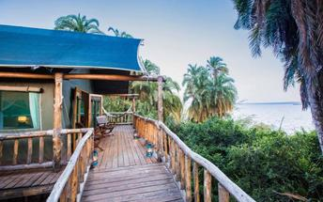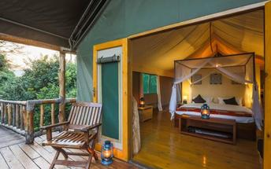

### Activities

|  |
| --- |
| Kigali Genocide Memorial & Museum |

#### Kigali Genocide Memorial & Museum

Located just outside of Kigali City Centre in the Gasabo district, Kigali Genocide Memorial & Museum was created by a joint partnership of the Kigali City Council and the UK-based Aegis Trust. The centre is an extremely moving, challenging, educational and ultimately inspiring as well as a great place to understand the cause, tragedy and successful rebuilding post-genocide.

The memorial hosts a tour which is transparent and educational but very sombre and humbling when guests realise that over 250,000 deceased are buried on the site of the memorial.

### Basis

Full Board - Dinner, Bed, Breakfast and Lunch

## Day 2: Ruzizi Tented Lodge, Akagera National Park

### Day Itinerary

* 0630: Begin the day with a morning breakfast.
* 0700: Morning **game drive** in Akagera National Park and other day activities by the lodge.
* 1600: Sunset **Boat safari in Akagera** on Lake Ihema
* 1800: Dinner and overnight stay at your Lodge

### Activities

|  |
| --- |
| Akagera National Park Game Drive |
| Boat Trip On Lake Ihema |

#### Akagera National Park Game Drive

Lead by a guide, Akagera National Park Game Drive occurs early in the mornings and late in the afternoons. While driving along the park tracks in a 4WD Safari vehicle, passengers will have the chance to spot animals such as hyenas, elephants, various buffalo and lions.

### Basis

Full Board - Dinner, Bed, Breakfast and Lunch

## Day 3: Virunga Inn Resort & Spa, Volcanoes National Park

### Volcanoes National Park

Bordering the Democratic Republic of Congo in Rwanda, and set high on the jungle-covered slopes of the volcanic Virunga Mountains, the Volcanoes National Park is best known as a sanctuary for the region’s rare mountain gorillas. Visitors flock here to experience face to face encounters with these intriguing creatures. Regulated treks through the reserve allow visitors to spend an hour at a time with these incredible primates in their natural habitat. While the gorillas are without a doubt the main drawcard, visitors can also look forward to exploring a network of scenic hiking trails, with the beautiful day hike to the crater lake on Mount Bisoke being a particular highlight. Make sure to visit the fascinating Karisoke Research Centre and the tomb of the world-famous Dian Fossey.

### Day Itinerary

* 0800: Begin the day with a morning breakfast.
* 0900: Ready to return to Kigali and transfer to Volcanoes.
* 1300: Lunch in Kigali.
* 1430: Continue to Volcanoes.
* 1800: **Estimated time of arrival and check in at your lodge.**
* 1800: Dinner and Overnight stay at your lodge.

### Overnight: Virunga Inn Resort & Spa

Located in Kinigi, Rwanda, Virunga Inn Resort & Spa offers stylish accommodations with beautiful views of the mountains. The property features beautifully appointed rooms equipped with comfortable bedding, a private bathroom, a flat-screen TV, a safety deposit box, and a seating area. The property also features a 24-hour front desk, free Wi-Fi throughout, room service, and a restaurant serving a tasty breakfast each morning.

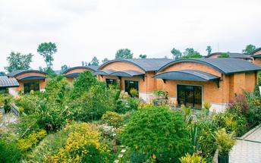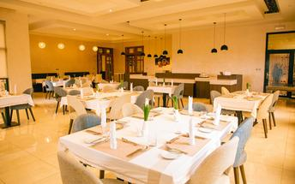

### Basis

Full Board - Dinner, Bed, Breakfast and Lunch

## Day 4: Virunga Inn Resort & Spa, Volcanoes National Park

### Day Itinerary

* 0600: Begin the day with a morning breakfast.
* 0630: Transfer to the park headquarters for gorilla trekking briefing.
* 0800: Start the **gorilla trekking in Volcanoes National Park.**
* 1200: Estimated time of returning from the jungle.
* 1230: Transfer back to the Lodge.
* 1300: Lunch at the Lodge.
* 1500: Visit **Iby ‘Iwacu cultural village.**
* 1800: Dinner and overnight stay at your lodge.

### Activities

|  |
| --- |
| Gorilla Trekking Volcanoes National Park |
| Iby'Iwacu Cultural Village |

#### Gorilla Trekking Volcanoes National Park

Gorilla Trekking in the Volcanoes National Park offers visitors the unique opportunity of discovering the 10 families of gorillas that live within the national park. Visitors can enjoy a cup of coffee before the trek starts and will be separated into groups of 8 depending on their physical abilities. Each group is guided by a guide and two scouts who are well trained in emergency situations. The amount of time set aside per trek is different depending on where the gorilla family is situated. Some trips may take as little as half an hour and some taking the better part of the day.

#### Iby'Iwacu Cultural Village

Offering an adventurous stay in a traditional rural, Rwandan village that has existed for centuries living with and next to mountain gorillas in Parc National des Volcans. Iby’Iwacu Cultural Village gives you a rare chance to meet local people, in their environment, with a taste of our culture and traditions. The community you visit will genuinely welcome you as a special guest while they proudly present to you aspects of their traditions and beliefs. This will truly be an experience of a lifetime as you home stay with the community and become part of their family

### Basis

Full Board - Dinner, Bed, Breakfast and Lunch

## Day 5: Lake Kivu Serena Hotel, Gisenyi

### Gisenyi

Situated at Lake Kivu’s northeast corner and neighbouring the Congolese city of Goma, Gisenyi is a scenic Rwandan town at the foot of fertile hills. The town offers an excellent variety of activities, including an array of watersports. Gorgeous beaches provide the perfect setting for leisurely days - the Gisenyi Public Beach offers a charming location for swimming and picnicking - along with numerous lovely restaurants. Visitors can kayak, boat, take hikes to see gorillas, or go on historical and cultural tours. Don’t miss the opportunity to meander through the atmospheric Main Market, go beer tasting at the brewery, or visit the local youth cultural center to see kids practice dance, music, and gymnastics.

### Day Itinerary

* 0800: Begin the day with a morning breakfast.
* 1030: Transfer to Gisenyi town.
* 1200:  Check in at your Lodge.
* 1300: Lunch at the Lodge.
* 1500: Afternoon **Kayaking on Lake Kivu.**
* 1800: Dinner and overnight stay.

### Overnight: Lake Kivu Serena Hotel

Serenely sited on the white sandy shores of Lake Kivu, the sixth largest lake in Africa, and surrounded by extensive tropical gardens, the tastefully open-plan Lake Kivu Serena Hotel offers the ideal week-end escape.

### Activities

|  |
| --- |
| Kingfisher Journeys Lake Kivu Kayaking |

#### Kingfisher Journeys Lake Kivu Kayaking

The lush northern coastline of Lake Kivu between Gisenyi and Kibuye has some of the most spectacular scenery, peace and tranquillity in Rwanda! Just a couple of hours from the gorillas Lake Kivu’s blue water is the jewel beside the Virunga volcanoes. Classic Lake Kivu fishing boats ply the waters at sunset, their crews singing rhythmically as a traditional way of life flourishes along the verdant shore. Numerous birds dart in and out of bushes and the active Nyiragongo Volcano can be seen rising above the surrounding hills.

### Basis

Full Board - Dinner, Bed, Breakfast and Lunch

## Day 6: One & Only Nyungwe House, Nyungwe Forest National Park

### Nyungwe Forest National Park

Situated in southwestern Rwanda, the Nyungwe Forest National Park is known for its exceptional biodiversity and its wide range of endemic species. The park is composed of lush tracts of rainforest set high up on fertile mountain slopes. It is one of Africa’s most ancient forests and the home of Rwanda’s sole remaining chimpanzee population, as well as 85 additional mammal species, 43 reptile species, nearly 300 bird species and over 1000 plant species. Visitors can enjoy spotting colobus monkeys and chimpanzees hiding in the trees, hiking on a well-maintained network of trails passing through lush equatorial rainforest and catching a glimpse of a beautiful array of colourful birdlife. Don’t miss the thrilling Canopy Walk; it is one of its kind in Africa and offers impressive views of the forest.

### Day Itinerary

* 0800: Begin the day with a morning breakfast.
* 0900: Prepare for a transfer to Nyungwe
* 1300: Estimated time to arrive at Nyungwe
* 1330: Take Lunch at the Lodge.
* 1​600: Afternoon relaxation at your lodge.
* 1830: Overnight stay at the hotel.

### Overnight: One & Only Nyungwe House

Nestled on the edge of the vast and ancient Nyungwe rainforest, within the lush green expanse of a working tea plantation, One&Only Nyungwe House in Rwanda offers guests the opportunity to go where few have gone before, with once-in-a-lifetime experiences in one of the world’s most exceptional natural locations. Immersed in wild beauty surrounded by awe-inspiring jungle views, every element of the resort has been carefully considered, with inspired farm-to-table dining, spa and wellness offerings that embrace nature and local traditions, and curated, authentic experiences to discover.

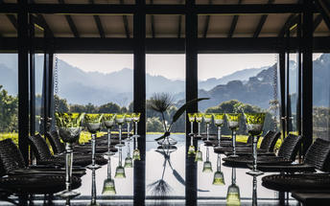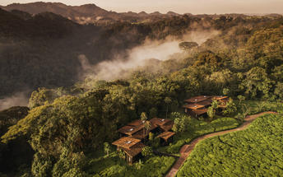

### Basis

Bed and Breakfast

## Day 7: One & Only Nyungwe House, Nyungwe Forest National Park

### Day Itinerary

* 0500: Begin the day with a morning breakfast.
* 0530: Prepare for transfers to Park headquarters for Chimpanzee trek briefing.
* 0530: Start the **Chimpanzee trekking in Nyungwe forests.**
* 1230: Estimated time to return from the jungle.
* 1330: Lunch at the Lodge and an entire day relaxing and winding at the Lodge.
* 1500: Take on a **Canopy Walk experience.**
* 1800: Dinner at the Resort.

### Activities

|  |
| --- |
| One & Only Nyungwe House Chimpanzee Trekking |
| Canopy Walk |

#### One & Only Nyungwe House Chimpanzee Trekking

Offered by the One&Only Ngungwe House, Chimpanzee Trekking is an exciting activity whereby guests will dash through the flora to encounter the chimpanzees playing in the wild within the Ngungwe National Park. With a maximum of 8 people per tour, the Chimpanzee trekking is a popular and challenging adventure, but due to the authentic nature of the experience, chimpanzee viewing is not a guarantee.

#### Canopy Walk

Suspended above ravine amidst the lush vegetation and montane forest of the Ngungwe National Park, Canopy Walk offers participants an exhilarating perspective atop the ancient treetops and wildlife. The 160 meters long suspended bridge is accessible as apart of a guided hike along the Igishigishigi trail or those hiking the Imbaraga and Umuyove trails.

### Basis

Bed and Breakfast

## Day 8: End of Itinerary

### Day Itinerary

* 0800: Begin the day with a morning breakfast.
* 0930: Prepare for a return transfer back to Kigali.
* 1100: Visit the **Ethnographic Museum**.
* 1200: An early lunch at the Lodge.
* 1420: Return to Kigali at your convenience
* 1700: Proposed time of arrival in Kigali and transfer to Kigali International Airport.
* TBA: Check in for your outbound flight to your next destination.
* End of service

### Activities

|  |
| --- |
| Ethnographic Museum Rwanda |

#### Ethnographic Museum Rwanda

Located in Huye, south of Kigali, Ethnographic Museum is one of the six museums that make up the Institute of National Museums of Rwanda. This Museum was built in 1987, and now houses one of Africa's finest ethnographic collections. Its seven galleries display historical, ethnographic, artistic and archaeological artefacts accompanied by visual aids, giving visitors a rich insight into the culture of Rwandans.

### Basis

Bed and Lunch

# Transport

## Transfers

|  |  |  |  |  |  |
| --- | --- | --- | --- | --- | --- |
| **Date** | **Company** | **Pick Up** | **Drop Off** | **Time** | **Vehicle** |
|  |  | Kigali International Airport [KGL] | Ruzizi Tented Lodge |  | Transfer |
|  |  | Ruzizi Tented Lodge | Virunga Inn Resort & Spa |  | Transfer |
|  |  | Virunga Inn Resort & Spa | Lake Kivu Serena Hotel |  | Transfer |
|  |  | Lake Kivu Serena Hotel | One & Only Nyungwe House |  | Transfer |
|  |  | One & Only Nyungwe House | Kigali International Airport [KGL] |  | Transfer |